

AP® Physics B
2000 Free response Questions

The materials included in these files are intended for use by AP teachers for course
and exam preparation in the classroom; permission for any other use must be
sought from the Advanced Placement Program®. Teachers may reproduce them, in whole or in part, in limited quantities, for face-to-face teaching purposes but may
not mass distribute the materials, electronically or otherwise. These materials and
any copies made of them may not be resold, and the copyright notices must be
retained as they appear here. This permission does not apply to any third-party copyrights contained herein.

These materials were produced by Educational Testing Service® (ETS®), which develops and administers the examinations of the Advanced Placement
Program for the College Board. The College Board and Educational Testing Service (ETS) are dedicated to the principle of equal opportunity, and their
programs, services, and employment policies are guided by that principle.

The College Board is a national nonprofit membership association dedicated to preparing, inspiring, and connecting students to college and opportunity.
Founded in 1900, the association is composed of more than 4,200 schools, colleges, universities, and other educational organizations. Each year, the
College Board serves over three million students and their parents, 22,000 high schools, and 3,500 colleges, through major programs and services in
college admission, guidance, assessment, financial aid, enrollment, and teaching and learning. Among its best-known programs are the SAT®, the
PSAT/NMSQT®, and the Advanced Placement Program® (AP®). The College Board is committed to the principles of equity and
excellence, and that commitment is embodied in all of its programs, services, activities, and concerns.

APIEL is a trademark owned by the College Entrance Examination Board. PSAT/NMSQT is a registered trademark jointly owned by the College Entrance Examination Board and the National Merit Scholarship Corporation. Educational Testing Service and ETS are registered trademarks of Educational Testing Service.

2000B1. A 0.50 kg cart moves on a straight horizontal track. The graph of velocity v versus time t for the cart is given below.
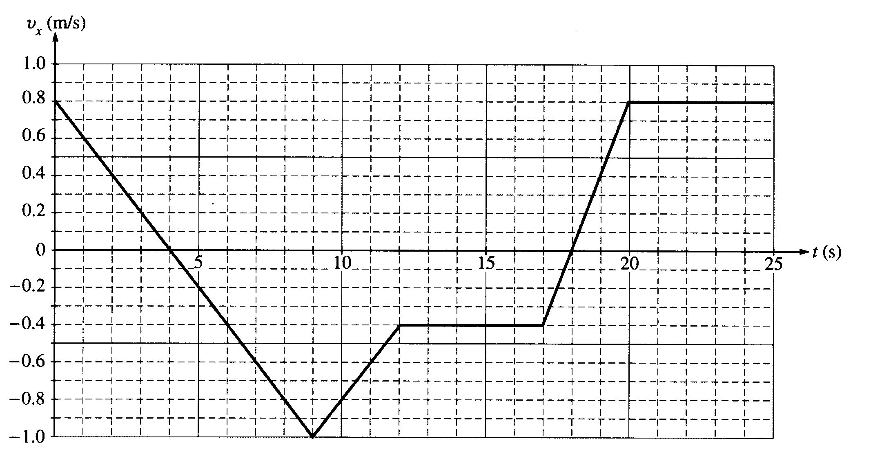
a. Indicate every time t for which the cart is at rest.
b. Indicate every time interval for which the speed (magnitude of velocity) of the cart is increasing.
c. Determine the horizontal position x of the cart at t = 9.0 s if the cart is located at x = 2.0 m at t = 0. d. On the axes below, sketch the acceleration a versus time t graph for the motion of the cart from t = 0 to t = 25 s.
e. From t = 25 s until the cart reaches the end of the track, the cart continues with constant horizontal velocity. The cart leaves the end of the track and hits the floor, which is 0.40 m below the track. Neglecting air resistance, determine each of the following:
i. The time from when the cart leaves the track until it first hits the floor
ii. The horizontal distance from the end of the track to the point at which the cart first hits the floor
iii. The kinetic energy of the cart immediately before it hits the floor
2000B2. Blocks 1 and 2 of masses m_{l} and m₂, respectively, are connected by a light string, as shown above. These blocks are further connected to a block of mass M by another light string that passes over a pulley of negligible mass and friction. Blocks l and 2 move with a constant velocity v down the inclined plane, which makes an angle θ with the horizontal. The kinetic frictional force on block 1 is f and that on block 2 is 2f.
a. On the figure below, draw and label all the forces on block m_{l}.
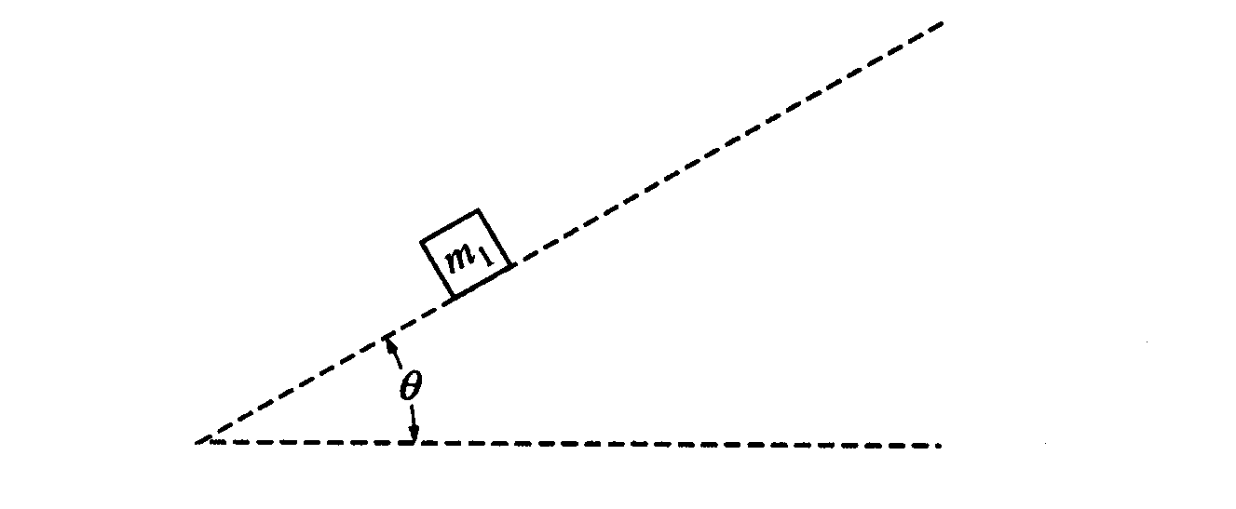
Express your answers to each of the following in terms of m_{l}, m₂, g, θ, and f.
b. Determine the coefficient of kinetic friction between the inclined plane and block 1.
c. Determine the value of the suspended mass M that allows blocks 1 and 2 to move with constant velocity down the plane.
d. The string between blocks 1 and 2 is now cut. Determine the acceleration of block 1 while it is on the inclined plane.

2000B3. Three identical resistors, each with resistance R, and a capacitor of 1.0 x 10⁻⁹ F are connected to a 30 V battery with negligible internal resistance, as shown in the circuit diagram above. Switches S_{I} and S₂ are initially closed, and switch S₃ is initially open. A voltmeter is connected as shown.
a. Determine the reading on the voltmeter.
b. Switches S_{l} and S₂ are now opened, and then switch S₃ is closed. Determine the charge Q on the capacitor after S₃ has been closed for a very long time.

After the capacitor is fully charged, switches S₁ and S₂ remain open, switch S₃ remains closed, the plates are held
fixed, and a conducting copper block is inserted midway between the plates, as shown below. The plates of the capacitor are separated by a distance of 1.0 mm, and the copper block has a thickness of 0.5 mm.
c. i. What is the potential difference between the plates?
ii. What is the electric field inside the copper block?
iii. On the diagram above, draw arrows to clearly indicate the direction of the electric field between the plates. iv. Determine the magnitude of the electric field in each of the spaces between the plates and the copper block.

2000B4. A sheet of glass has an index of refraction n_{g} = 1.50. Assume that the index of refraction for air is n_{a} = 1.00.

a. Monochromatic light is incident on the glass sheet, as shown in the figure below, at an angle of incidence of 60°. On the figure, sketch the path the light takes the first time it strikes each of the two parallel surfaces. Calculate and label the size of each angle (in degrees) on the figure, including angles of incidence, reflection, and refraction at each of the two parallel surfaces shown.
b. Next a thin film of material is to be tested on the glass sheet for use in making reflective coatings. The film
has an index of refraction n _{f} = 1.38. White light is incident normal to the surface of the film as shown
below. It is observed that at a point where the light is incident on the film, light reflected from the surface
appears green (λ = 525 nm).

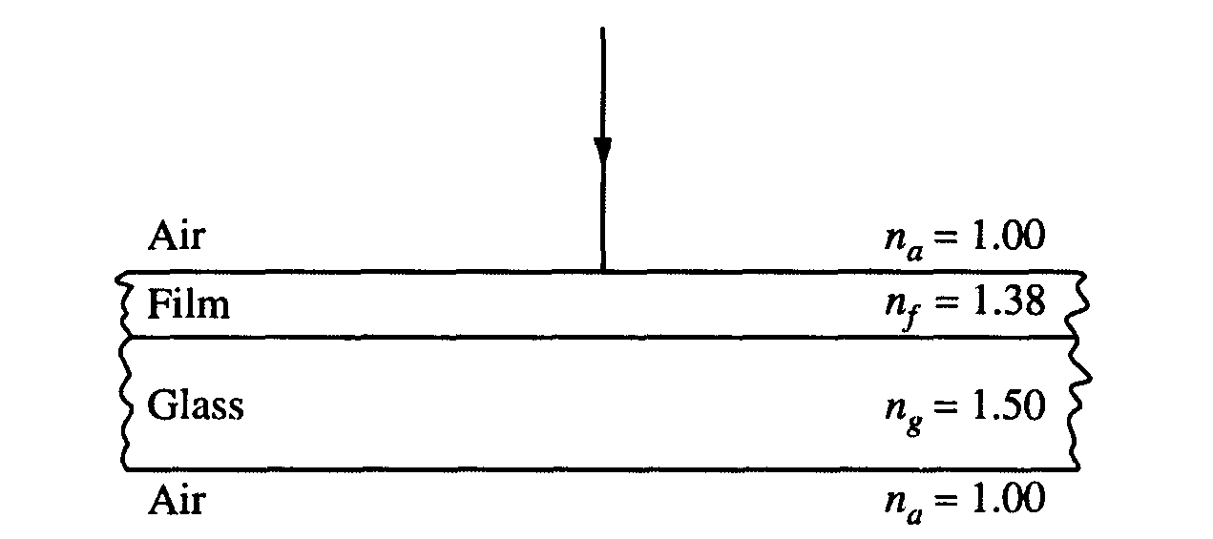

i. What is the frequency of the green light in air?
ii. What is the frequency of the green light in the film?
iii. What is the wavelength of the green light in the film?
iv. Calculate the minimum thickness of film that would produce this green reflection.

2000B5 (10 Points) A sodium photoelectric surface with work function 2.3 eV is illuminated by electromagnetic radiation and emits electrons. The electrons travel toward a negatively charged cathode and complete the circuit shown above. The potential difference supplied by the power supply is increased, and when it reaches 4.5 V, no electrons reach the cathode.
a. For the electrons emitted from the sodium surface, calculate the following.
i. The maximum kinetic energy
ii. The speed at this maximum kinetic energy
b. Calculate the wavelength of the radiation that is incident on the sodium surface.
c. Calculate the minimum frequency of light that will cause photoemission from this sodium surface.
2000B6 (10 points) You are to design a procedure to determine experimentally the specific heat of an unknown liquid. You may not damage or destroy any equipment you use, and your method must be feasible and practical.

a. List the equipment you would need. Include a labeled diagram.
b. Describe the measurements you would make. Assign each measurement a symbol (such as time = t).
c. Show explicitly using equations how the measured quantities would be used to determine the specific heat of the unknown liquid.
d. Indicate one possible source of experimental error and discuss how it would affect your value for the specific heat. Justify your answer.

2000B7 (10 points) A particle with unknown mass and charge moves with constant speed v = 1.9 x 10⁶ m/s as it passes undeflected through a pair of parallel plates, as shown above. The plates are separated by a distance d = 6.0 x 10⁻³ m, and a constant potential difference V is maintained between them. A uniform magnetic field of magnitude B = 0.20 T directed into the page exists both between the plates and in a region to the right of them as shown. After the particle passes into the region to the right of the plates where only the magnetic field exists, its trajectory is circular with radius r = 0.10 m.

a. What is the sign of the charge of the particle? Check the appropriate space below.
___ Positive ___ Negative ___ Neutral ___ It cannot be determined from this information.

Justify your answer.

b. On the diagram above, clearly indicate the direction of the electric field between the plates.
c. Determine the magnitude of the potential difference V between the plates.
d. Determine the ratio of the charge to the mass (q/m) of the particle.

