

AP® Physics B
2001 Free response Questions

The materials included in these files are intended for use by AP teachers for course
and exam preparation in the classroom; permission for any other use must be
sought from the Advanced Placement Program®. Teachers may reproduce them, in whole or in part, in limited quantities, for face-to-face teaching purposes but may
not mass distribute the materials, electronically or otherwise. These materials and
any copies made of them may not be resold, and the copyright notices must be
retained as they appear here. This permission does not apply to any third-party copyrights contained herein.

These materials were produced by Educational Testing Service® (ETS®), which develops and administers the examinations of the Advanced Placement
Program for the College Board. The College Board and Educational Testing Service (ETS) are dedicated to the principle of equal opportunity, and their
programs, services, and employment policies are guided by that principle.

The College Board is a national nonprofit membership association dedicated to preparing, inspiring, and connecting students to college and opportunity.
Founded in 1900, the association is composed of more than 4,200 schools, colleges, universities, and other educational organizations. Each year, the
College Board serves over three million students and their parents, 22,000 high schools, and 3,500 colleges, through major programs and services in
college admission, guidance, assessment, financial aid, enrollment, and teaching and learning. Among its best-known programs are the SAT®, the
PSAT/NMSQT®, and the Advanced Placement Program® (AP®). The College Board is committed to the principles of equity and
excellence, and that commitment is embodied in all of its programs, services, activities, and concerns.

APIEL is a trademark owned by the College Entrance Examination Board. PSAT/NMSQT is a registered trademark jointly owned by the College Entrance Examination Board and the National Merit Scholarship Corporation. Educational Testing Service and ETS are registered trademarks of Educational Testing Service.

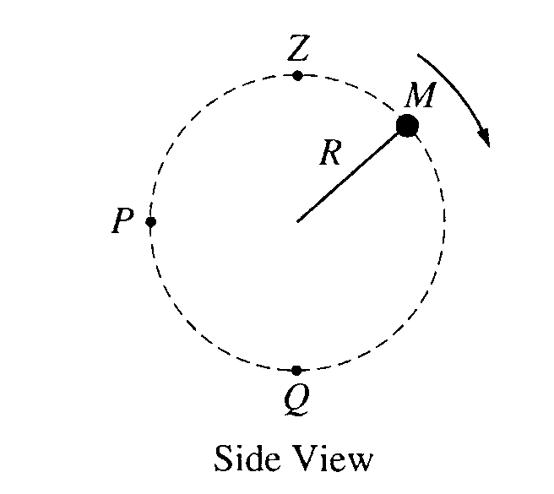
2001B1. A ball of mass M is attached to a string of length R and negligible mass. The ball moves clockwise in a vertical circle, as shown above. When the ball is at point P, the string is horizontal. Point Q is at the bottom of the circle and point Z is at the top of the circle. Air resistance is negligible. Express all algebraic answers in terms of the given quantities and fundamental constants.

a. On the figures below, draw and label all the forces exerted on the ball when it is at points P and Q, respectively.
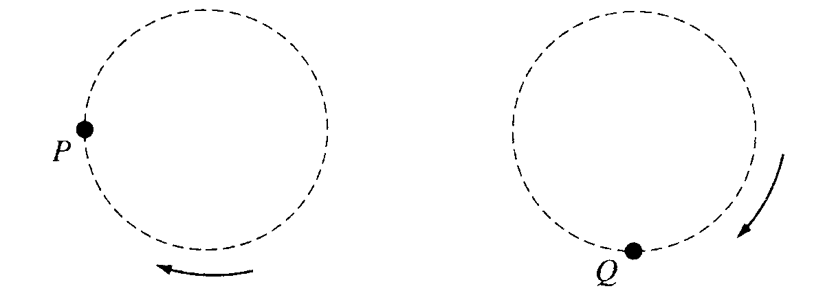
b. Derive an expression for v_{min} the minimum speed the ball can have at point Z without leaving the circular path.
c. The maximum tension the string can have without breaking is T_{max} Derive an expression for v_{max}, the maximum speed the ball can have at point Q without breaking the string.
d. Suppose that the string breaks at the instant the ball is at point P. Describe the motion of the ball immediately after the string breaks.

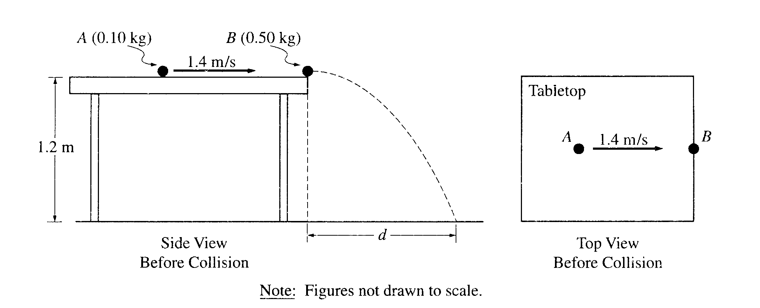
2001B2. An incident ball A of mass 0.10 kg is sliding at 1.4 m/s on the horizontal tabletop of negligible friction shown above. It makes a head-on collision with a target ball B of mass 0.50 kg at rest at the edge of the table. As a result of the collision, the incident ball rebounds, sliding backwards at 0.70 m/s immediately after the collision.
a. Calculate the speed of the 0.50 kg target ball immediately after the collision.

The tabletop is 1.20 m above a level, horizontal floor. The target ball is projected horizontally and initially strikes the floor at a horizontal displacement d from the point of collision.
b. Calculate the horizontal displacement d.

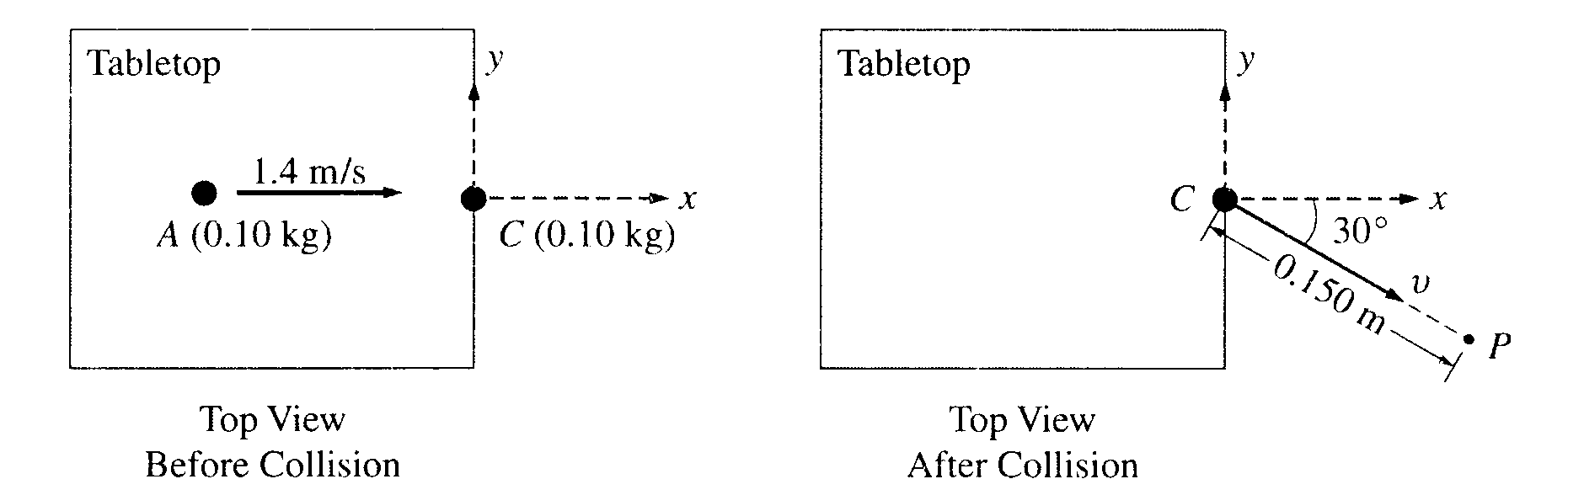
In another experiment on the same table, the target ball B is replaced by target ball C of mass 0.10 kg. The incident ball A again slides at 1.4 m/s, as shown above left, but this time makes a glancing collision with the target ball C that is at rest at the edge of the table. The target ball C strikes the floor at point P, which is at a horizontal displacement of 0.15 m from the point of the collision, and at a horizontal angle of 30° from the +x-axis, as shown above right.
c. Calculate the speed v of the target ball C immediately after the collision.
d. Calculate the y-component of incident ball A's momentum immediately after the collision.
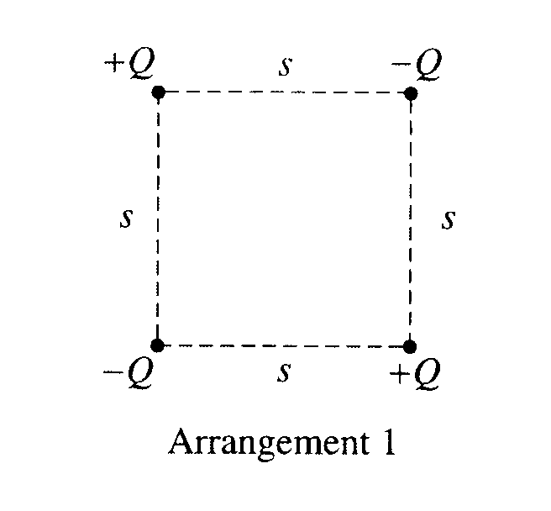
2001B3. Four charged particles are held fixed at the corners of a square of side s. All the charges have the same magnitude Q, but two are positive and two are negative. In Arrangement 1, shown above, charges of the same sign are at opposite corners. Express your answers to parts a. and b. in terms of the given quantities and fundamental constants.
a. For Arrangement 1, determine the following.
i. The electrostatic potential at the center of the square
ii. The magnitude of the electric field at the center of the square
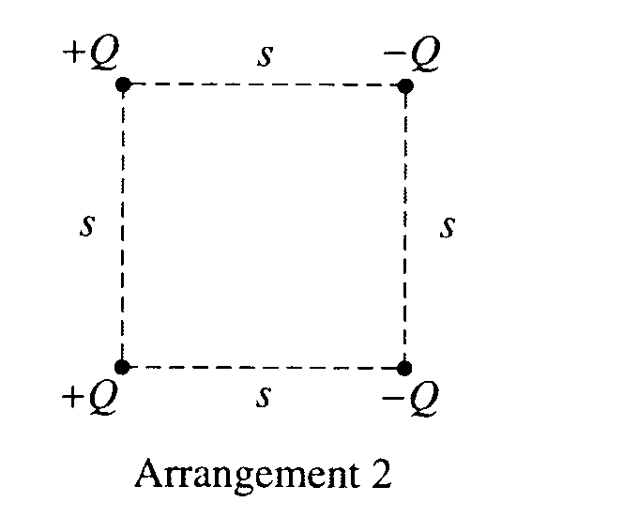
The bottom two charged particles are now switched to form Arrangement 2, shown above, in which the positively charged particles are on the left and the negatively charged particles are on the right.
b. For Arrangement 2, determine the following.
i. The electrostatic potential at the center of the square
ii. The magnitude of the electric field at the center of the square
c. In which of the two arrangements would more work be required to remove the particle at the upper right
corner from its present position to a distance a long way away from the arrangement?

_________ Arrangement 1 ___________ Arrangement 2

Justify your answer

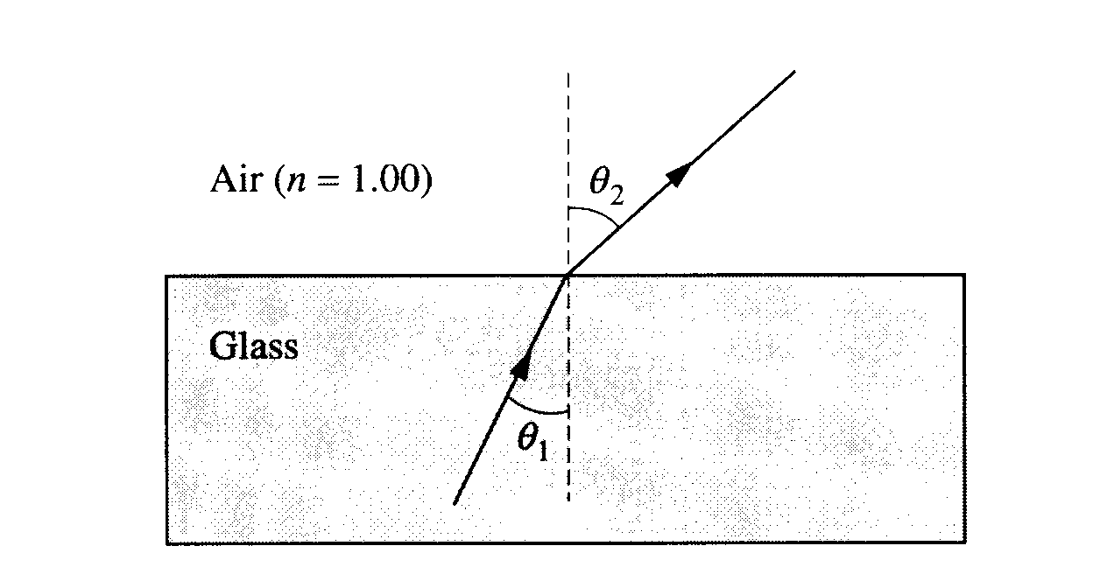
2001B4. In an experiment a beam of red light of wavelength 675 nm in air passes from glass into air, as shown above. The incident and refracted angles are θ₁ and θ₂ , respectively. In the experiment, angle θ₂ is measured for various angles of incidence θ₁, and the sines of the angles are used to obtain the line shown in the following graph.

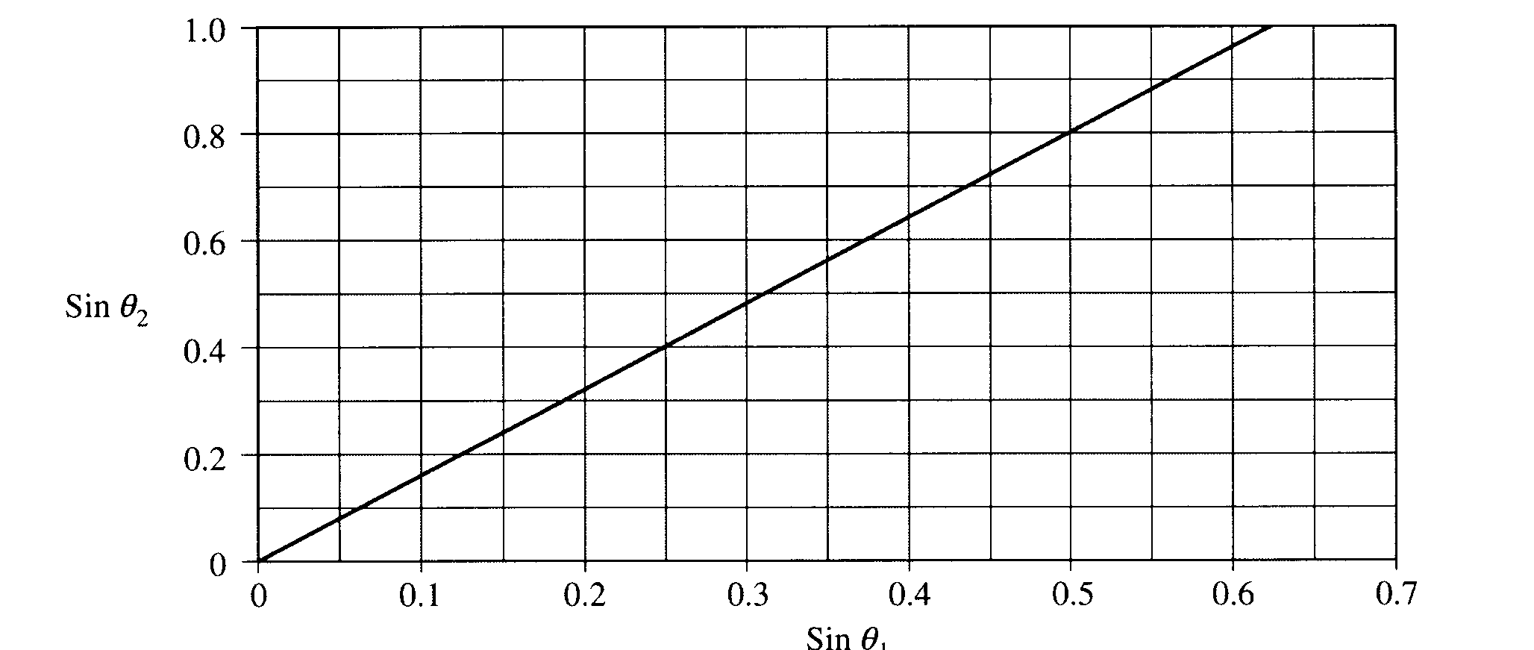
a. Assuming an index of refraction of 1.00 for air, use the graph to determine a value for the index of refraction
of the glass for the red light. Explain how you obtained this value.
b. For this red light, determine the following.
i. The frequency in air
ii. The speed in glass
iii. The wavelength in glass
c. The index of refraction of this glass is 1.66 for violet light, which has wavelength 425 nm in air.
i. Given the same incident angle θ₁, show on the ray diagram on the previous page how the refracted ray for the violet light would vary from the refracted ray already drawn for the red light.
ii. Sketch the graph of sin θ₂ versus sin θ₁ for the violet light on the figure on the previous page that shows the same graph already drawn for the red light.
d. Determine the critical angle of incidence θ_{c}, for the violet light in the glass in order for total internal reflection to occur.
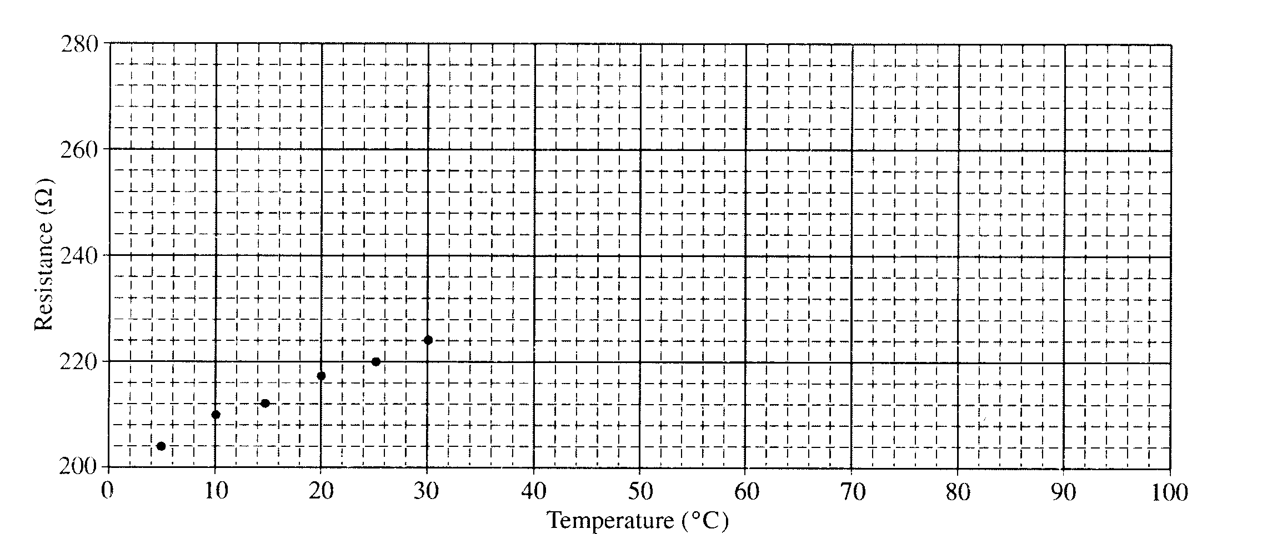
2001B5 (10 points) A platinum resistor has a resistance that changes with temperature. Values of the resistance were obtained experimentally for several temperatures from 5°C to 30°C only and plotted on the graph above. Design a procedure in which this resistor can be used as a thermometer to measure the temperature of a liquid that is in the 50°C to 75°C range. The resistor can be safely immersed in liquids. Along with the resistor and the container of the liquid of unknown temperature, the following equipment and materials may be used.

Power supply
Ammeter (Note: The ammeter and the voltmeter cannot
Voltmeter be used directly as an ohmmeter.)
Connecting wires
Ice-water bath
Boiling-water bath

a. Sketch a diagram (with labels) to show how equipment is to be connected to make the necessary measurements, and briefly outline the steps to be followed.
b. Discuss what measurements will be taken to determine the temperature of the unknown liquid.
c. Discuss one assumption that must be made regarding equipment or procedure in order to use the method you have described.

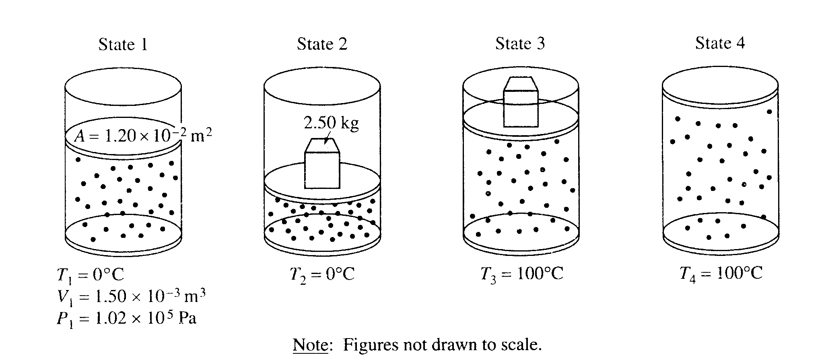
2001B6 (10 points) A cylinder is fitted with a freely moveable piston of area 1.20 x 10⁻² m² and negligible mass. The cylinder below the piston is filled with a gas. At state 1, the gas has volume 1.50 x 10⁻³ m³, pressure 1.02 x 10⁵ Pa, and the cylinder is in contact with a water bath at a temperature of 0°C. The gas is then taken through the following four-step process.

• A 2.50 kg metal block is placed on top of the piston, compressing the gas to state 2, with the gas still at 0°C.
• The cylinder is then brought in contact with a boiling water bath, raising the gas temperature to 100°C at state 3.
• The metal block is removed and the gas expands to state 4 still at 100°C.
• Finally, the cylinder is again placed in contact with the water bath at 0°C, returning the system to state 1.

a. Determine the pressure of the gas in state 2.
b. Determine the volume of the gas in state 2.
c. Indicate below whether the process from state 2 to state 3 is isothermal, isobaric, or adiabatic.

_____Isothermal _____Isobaric _____Adiabatic
Explain your reasoning.

d. Is the process from state 4 to state 1 isobaric? _____Yes _____No
Explain your reasoning.

e. Determine the volume of the gas in state 4.

2001B7 (10 points) Consider the following nuclear fusion reaction that uses deuterium as fuel.
a. Determine the mass defect of a single reaction, given the following information.
b. Determine the energy in joules released during a single fusion reaction.
c. The United States requires about 10²⁰ J per year to meet its energy needs. How many deuterium atoms would be necessary to provide this magnitude of energy?
d. Assume that 0.015% of the hydrogen atoms in seawater (H₂0) are deuterium. The atomic mass number of oxygen is 16. About how many kilograms of seawater would be needed per year to provide the hydrogen fuel for fusion reactors to meet the energy needs of the United States?

