

AP® Physics B (Form B)
2003 Free response Questions

The materials included in these files are intended for use by AP teachers for course and exam preparation in the classroom; permission for any other use must be sought from the Advanced Placement Program®. Teachers may reproduce them, in whole or in part, in limited quantities, for face-to-face teaching purposes but may not mass distribute the materials, electronically or otherwise. These materials and any copies made of them may not be resold, and the copyright notices must be retained as they appear here. This permission does not apply to any third-party copyrights contained herein.

These materials were produced by Educational Testing Service® (ETS®), which develops and administers the examinations of the Advanced Placement
Program for the College Board. The College Board and Educational Testing Service (ETS) are dedicated to the principle of equal opportunity, and their
programs, services, and employment policies are guided by that principle.

The College Board is a national nonprofit membership association dedicated to preparing, inspiring, and connecting students to college and opportunity.
Founded in 1900, the association is composed of more than 4,200 schools, colleges, universities, and other educational organizations. Each year, the
College Board serves over three million students and their parents, 22,000 high schools, and 3,500 colleges, through major programs and services in
college admission, guidance, assessment, financial aid, enrollment, and teaching and learning. Among its best-known programs are the SAT®, the
PSAT/NMSQT®, and the Advanced Placement Program® (AP®). The College Board is committed to the principles of equity and
excellence, and that commitment is embodied in all of its programs, services, activities, and concerns.

APIEL is a trademark owned by the College Entrance Examination Board. PSAT/NMSQT is a registered trademark jointly owned by the College Entrance Examination Board and the National Merit Scholarship Corporation. Educational Testing Service and ETS are registered trademarks of Educational Testing Service.
2003Bb1. (15 points) An airplane accelerates uniformly from rest. A physicist passenger holds up a thin string of negligible mass to which she has tied her ring, which has a mass m. She notices that as the plane accelerates down the runway, the string makes an angle θ with the vertical as shown above.
a. In the space below, draw a free-body diagram of the ring, showing and labeling all the forces present.

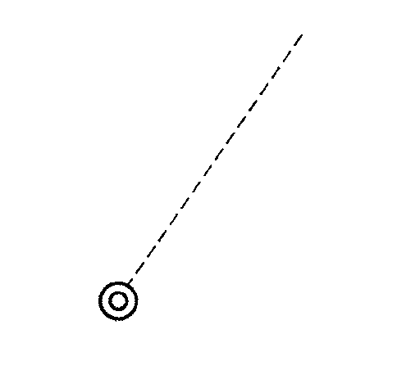

The plane reaches a takeoff speed of 65 m/s after accelerating for a total of 30 s.

b. Determine the minimum length of the runway needed.
c. Determine the angle B that the string makes with the vertical during the acceleration of the plane before it leaves the ground.
d. What additional information would be needed in order to estimate the mechanical energy of the airplane at the instant of takeoff? Explain your answer.

2003Bb2. (15 points) A student is asked to design a circuit to supply an electric motor with 1.0 mA of current at 3.0 V potential difference.
a. Determine the power to be supplied to the motor.
b. Determine the electrical energy to be supplied to the motor in 60 s.
c. Operating as designed above, the motor can lift a 0.012 kg mass a distance of 1.0 m in 60 s at constant velocity. Determine the efficiency of the motor.

To operate the motor, the student has available only a 9.0 V battery to use as the power source and the following five resistors.

d. In the space below, complete a schematic diagram of a circuit that shows how one or more of these resistors can be connected to the battery and motor so that 1.0 mA of current and 3.0 V of potential difference are supplied to the motor. Be sure to label each resistor in the circuit with the correct value of its resistance.
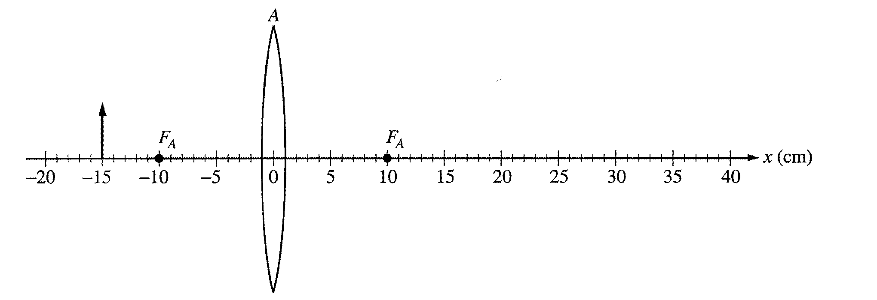
2003Bb3. (15 points) A thin convex lens A of focal length f_{A} = 10 cm is positioned on an x-axis as shown above. An object of height 5 cm, represented by the arrow, is positioned 15 cm to the left of lens A.
a. On the figure above, draw necessary rays and sketch the image produced by lens A.
b. Calculate the location of the image produced by lens A.
c. Calculate the height of the image produced by lens A.

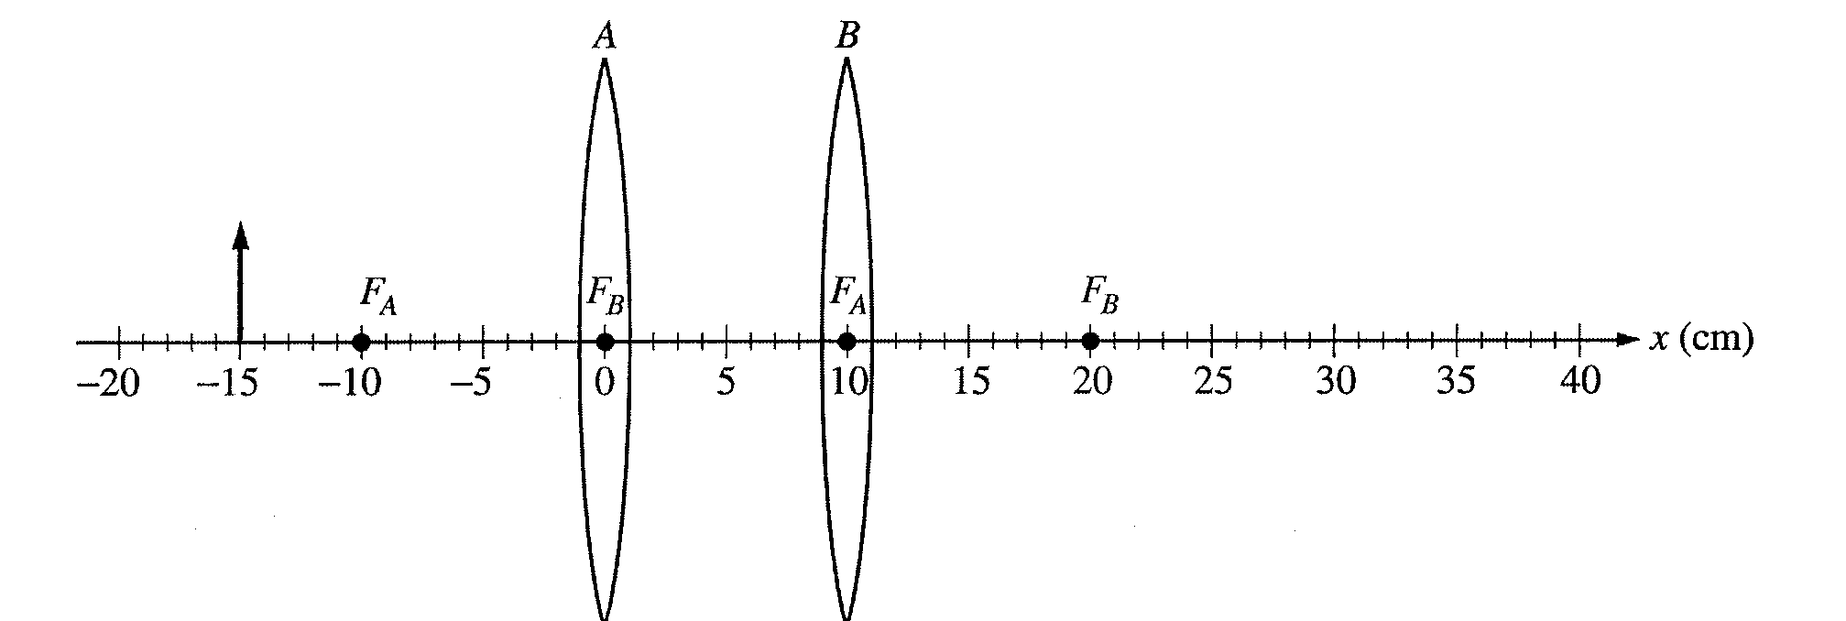

A second thin convex lens B of focal length f _{B} = 10 cm is now positioned 10 cm to the right of lens A, as
shown above.
d. Determine the location on the x-axis given above of the final image produced by the combination of lenses.
e. Check the appropriate spaces below to indicate the characteristics of the final image produced by
the combination of lenses.
_____inverted _____larger than the original object
_____upright _____smaller than the original object

Explain your answers.

2003Bb4. (15 points) An electric field E exists in the region between the two electrically charged parallel plates shown above.
A beam of electrons of mass m, charge q, and velocity v enters the region through a small hole at position A.
The electrons exit the region between the plates through a small hole at position B. Express your answers to
the following questions in terms of the quantities m, q, E, θ, and v. Ignore the effects of gravity.

a.
i. On the diagram of the parallel plates above, draw and label a vector to show the direction of the electric field E between the plates.
ii. On the following diagram, show the direction of the force(s) acting on an electron after it enters the region between the plates.


iii. On the diagram of the parallel plates above, show the trajectory of an electron that will exit through the small hole at position B.
b. Determine the magnitude of the acceleration of an electron after it has entered the region between the parallel plates.
c. Determine the total time that it takes the electrons to go from position A to position B.
d. Determine the distance d between positions A and B.
e. Now assume that the effects of gravity cannot be ignored in this problem. How would the distance d change for an electron entering the region at A and leaving at B? Explain your reasoning.
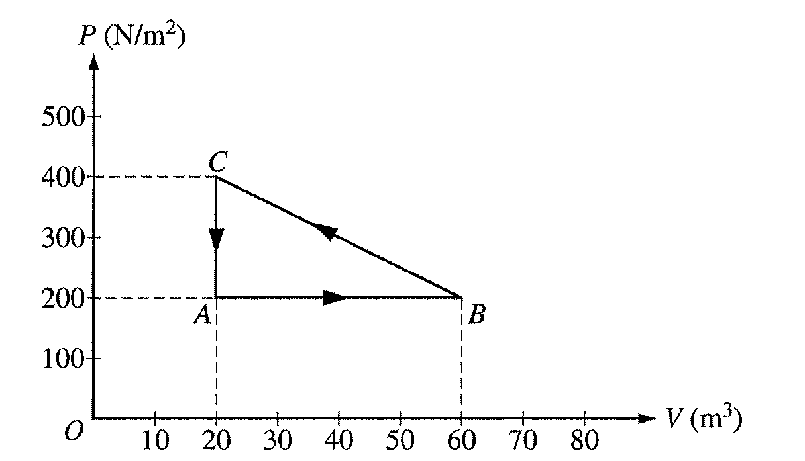

2003Bb5. (10 points) One mole of an ideal gas is taken around the cycle A→B→C→A as shown on the PV diagram above.
a. Calculate the temperature of the gas at point A.
b. Calculate the net work done on the gas during one complete cycle.
c. i. Is heat added to or removed from the gas during one complete cycle?
_____added to the gas _____removed from the gas
ii. Calculate the heat added to or removed from the gas during one complete cycle.
d. After one complete cycle, is the internal energy of the gas greater, less, or the same as before?
_____greater _____less _____the same
Justify your answer.
e. After one complete cycle, is the entropy of the gas greater, less, or the same as before?
_____greater _____less _____the same
Justify your answer.

2003Bb6. (10 points) A pump, submerged at the bottom of a well that is 35 m deep, is used to pump water uphill to a house that is 50 m above the top of the well, as shown above. The density of water is 1,000 kg/m³. All pressures are gauge
pressures. Neglect the effects of friction, turbulence, and viscosity.
a. Residents of the house use 0.35 m3 of water per day. The day's pumping is completed in 2 hours during the day.
i. Calculate the minimum work required to pump the water used per day
ii. Calculate the minimum power rating of the pump.
b. The average pressure the pump actually produces is 9.20 x 10⁵ N/m². Within the well the water flows at 0.50 m/s and the pipe has a diameter of 3.0 cm. At the house the pipe diameter is 1.25 cm.
i. Calculate the flow velocity when a faucet in the house is open.
ii. Explain how you would calculate the minimum pressure at the faucet.

2003Bb7. (10 points)An experiment is performed on a sample of atoms known to have a ground state of -5.0 eV. The gas is illuminated with "white light" (400 - 700 nm). A spectrometer capable of analyzing radiation in this range is used to measure the radiation. The sample is observed to absorb light at only 400 nm. After the "white light" is turned off, the sample is observed to emit visible radiation of 400 nm and 600 nm.

a. In the space below, determine the values of the energy levels and on the following scale sketch an energy level diagram showing the energy values in eVs and the relative positions of:
i. the ground state
ii. the energy level to which the system was first excited
iii. one other energy level that the experiment suggests may exist

b. What is the wavelength of any other radiation, if any, that might have been emitted in the experiment? Why was it not observed?

