

AP® Physics B Form B

2004 Free Response Questions

The materials included in these files are intended for noncommercial use by AP teachers for course and exam preparation; permission for any other use must be sought from the
Advanced Placement Program®. Teachers may reproduce them, in whole or in part, in limited quantities, for face-to-face teaching purposes but may not mass distribute
the materials, electronically or otherwise. This permission does not apply to any third-party copyrights contained herein. These materials and any copies made of them
may not be resold, and the copyright notices must be retained as they appear here.

The College Board is a nonprofit membership association whose mission is to connect students to college success and opportunity.
Founded in 1900, the association is composed of more than 4,500 schools, colleges, universities, and other educational organizations. Each year, the
College Board serves over three million students and their parents, 23,000 high schools, and 3,500 colleges, through major programs and services in
college admissions, guidance, assessment, financial aid, enrollment, and teaching and learning. Among its best-known programs are the SAT®, the
PSAT/NMSQT®, and the Advanced Placement Program® (AP®). The College Board is committed to the principles of equity and
excellence, and that commitment is embodied in all of its programs, services, activities, and concerns.

For further information, visit www.collegeboard.com

College Board, Advanced Placement Program, AP, SAT, and the acorn logo are registered trademarks of the College Entrance Examination Board.

2004Bb1 (15 points) A designer is working on a new roller coaster, and she begins by making a scale model. On this model, a car of total mass 0.50 kg moves with negligible friction along the track shown in the figure above. The car is given an initial speed vo = 1.5 m/s at the top of the first hill of height 2.0 m. Point A is located at a height of 1.9 m at the top of the second hill, the upper part of which is a circular arc of radius 0.95 m.

(a) Calculate the speed of the car at point A.
(b) On the figure of the car below, draw and label vectors to represent the forces on the car at point A.
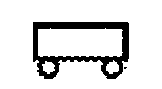
(c) Calculate the magnitude of the force of the track on the car at point A.
(d) In order to stop the car at point A, some friction must be introduced. Calculate the work that must be done
by the friction force in order to stop the car at point A.
(e) Explain how to modify the track design to cause the car to lose contact with the track at point A before
descending down the track. Justify your answer.

2004Bb2 (15 points) The experimental diving bell shown above is lowered from rest at the ocean's surface and reaches a maximum depth of 80 m. Initially it accelerates downward at a rate of 0.10 m/s² until it reaches a speed of 2.0 m/s, which then remains constant. During the descent, the pressure inside the bell remains constant at 1 atmosphere. The top of the bell has a cross-sectional area A = 9.0 m². The density of seawater is 1025 kg/m³ .

(a) Calculate the total time it takes the bell to reach the maximum depth of 80 m.
(b) Calculate the weight of the water on the top of the bell when it is at the maximum depth.
(c) Calculate the absolute pressure on the top of the bell at the maximum depth.

On the top of the bell there is a circular hatch of radius r = 0.25 m.
(d) Calculate the minimum force necessary to lift open the hatch of the bell at the maximum depth.
(e) What could you do to reduce the force necessary to open the hatch at this depth? Justify your answer.

2004Bb3 (15 points)
A vibrating tuning fork is held above a column of air, as shown in the diagrams above. The reservoir is raised and lowered to change the water level, and thus the length of the column of air. The shortest length of air column that produces a resonance is L₁ = 0.25 m, and the next resonance is heard when the air column is L₂ = 0.80 m long. The speed of sound in air at 20°C is 343 m/s and the speed of sound in water is 1490 m/s.

(a) Calculate the wavelength of the standing sound wave produced by this tuning fork.
(b) Calculate the frequency of the tuning fork that produces the standing wave, assuming the air is at 20°C.
(c) Calculate the wavelength of the sound waves produced by this tuning fork in the water.
(d) The water level is lowered again until a third resonance is heard. Calculate the length L₃ of the air column that produces this third resonance.
(e) The student performing this experiment determines that the temperature of the room is actually slightly higher than 20°C. Is the calculation of the frequency in part (b) too high, too low, or still correct?
_____Too high _____Too low _____Still correct
Justify your answer.

2004Bb4 (15 points) A 20-turn wire coil in the shape of a rectangle, 0.25 m by 0.15 m, has a resistance of 5.0 Ω. In position 1 shown above, the loop is in a uniform magnetic field B of 0.20 T. The field is directed out of the page, perpendicular to the plane of the loop. The loop is pulled to the right at a constant velocity, reaching position 2 in 0.50 s, where B is equal to zero.

(a) Calculate the average emf induced in the 20-turn coil during this period.
(b) Calculate the magnitude of the current induced in the 20-turn coil and state its direction.
(c) Calculate the power dissipated in the 20-turn coil.
(d) Calculate the magnitude of the average force necessary to remove the 20-turn coil from the magnetic field.
(e) Identical wire is used to add 20 more turns of wire to the original coil. How does this affect the current in the coil? Justify your answer.

2004Bb5 (10 points)
One mole of an ideal gas is initially at pressure P₁, volume V₁, and temperature T₁, represented by point A on
the PV diagram above. The gas is taken around cycle ABCA shown. Process AB is isobaric, process BC is isochoric, and process CA is isothermal.
(a) Calculate the temperature T₂ at the end of process AB in terms of temperature T₁.
(b) Calculate the pressure P₂ at the end of process BC in terms of pressure P₁.
(c) Calculate the net work done on the gas when it is taken from A to B to C. Express your answer in terms of P₁ and V₁.
(d) Indicate below all of the processes that result in heat being added to the gas.
____ AB ____ BC ____CA
Justify your answer.
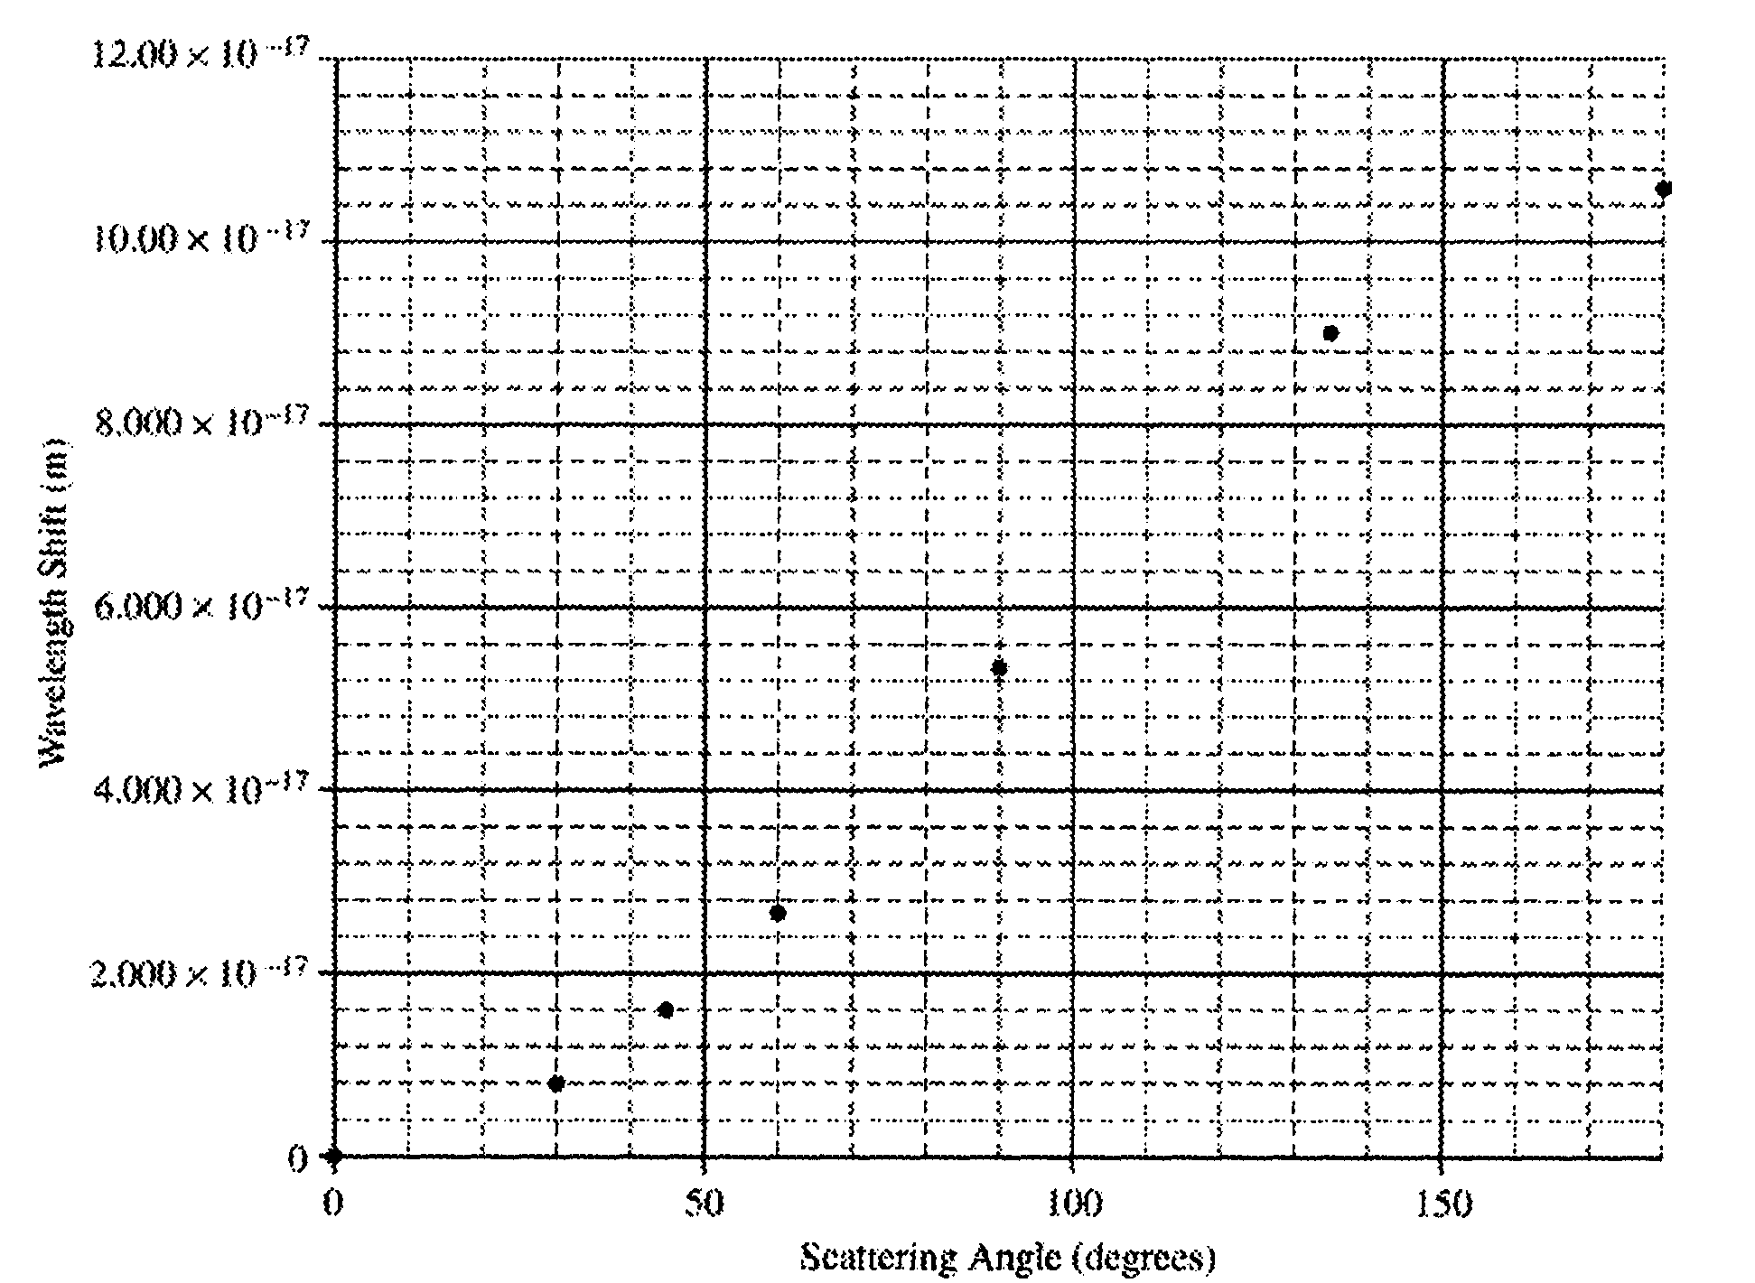
2004Bb6 (10 points)
An incident gamma ray photon of wavelength 1.400 x 10⁻¹⁴ m is scattered off a stationary nucleus. The shift in wavelength of the photon is measured for various scattering angles, and the results are plotted on the graph shown below.
(a) On the graph, sketch a best-fit curve to the data.
In one of the trials, the photon is scattered at an angle of 120° with its original direction.
(b) Calculate the wavelength of this photon after it is scattered off the nucleus.
(c) Calculate the momentum of this scattered photon.
(d) Calculate the energy that this scattering event imparts to the recoiling nucleus.

