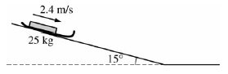
1. (15 points)

An empty sled of mass 25 kg slides down a muddy hill with a constant speed of 2.4 m/s. The slope of the hill is inclined at an angle of 15° with the horizontal as shown in the figure above.

(a) Calculate the time it takes the sled to go 21 m down the slope.

(b) On the dot below that represents the sled, draw and label a free-body diagram for the sled as it slides down the slope.

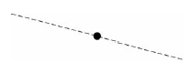

(c) Calculate the frictional force on the sled as it slides down the slope.

(d) Calculate the coefficient of friction between the sled and the muddy surface of the slope.

(e) The sled reaches the bottom of the slope and continues on the horizontal ground. Assume the same coefficient of friction.

i. In terms of velocity and acceleration, describe the motion of the sled as it travels on the horizontal ground.

ii. On the axes below, sketch a graph of speed v versus time t for the sled. Include both the sled’s travel down the slope and across the horizontal ground. Clearly indicate with the symbol t the time at which the sled leaves the slope.

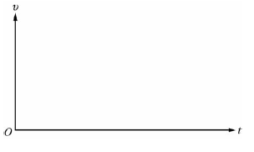

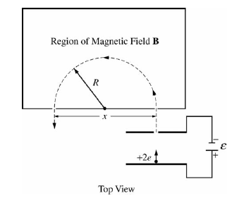
2. (10 points)

Your research director has assigned you to set up the laboratory’s mass spectrometer so that it will separate strontium ions having a net charge of +2e from a beam of mixed ions. The spectrometer above accelerates a beam of ions from rest through a potential difference ε, after which the beam enters a region containing a uniform magnetic field B of constant magnitude and perpendicular to the plane of the path of the ions. The ions leave the spectrometer at a distance x from the entrance point. You can manually change ε.
Numerical values for this experiment:
Strontium atomic number: 38
Strontium ion mass: 1.45x10⁻²⁵ kg
Magnitude of B field: 0.090 T
Desired exit distance x: 1.75 m

(a) In what direction must B point to produce the trajectory of the ions shown?

(b) The ions travel at constant speed around the semicircular path. Explain why the speed remains constant.

(c) Calculate the speed of the ions with charge +2e that exit at distance x.

(d) Calculate the accelerating voltage ε needed for the ions with charge +2e to attain the speed you calculated in part (c).

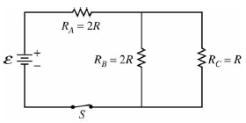

3. (15 points)

The circuit above contains a battery with negligible internal resistance, a closed switch S, and three resistors, each with a resistance of R or 2R.

(a)
i. Rank the currents in the three resistors from greatest to least, with number 1 being greatest. If two resistors have the same current, give them the same ranking.

____ I_{A} ____ I_{B} ____ I_{C}

ii. Justify your answers.

(b)
i. Rank the voltages across the three resistors from greatest to least, with number 1 being greatest. If two resistors have the same voltage across them, give them the same ranking.

____ V_{A} ____ V_{B} ___ V_{C}

ii. Justify your answers.

For parts (c) through (e), use ε = 12 V and R = 200 Ω.
(c) Calculate the equivalent resistance of the circuit.

(d) Calculate the current in resistor R_{C} .

(e) The switch S is opened, resistor R_{B} is removed and replaced by a capacitor of capacitance 2.0x10⁻⁶ F, and the switch S is again closed. Calculate the charge on the capacitor after all the currents have reached their final steady-state values.

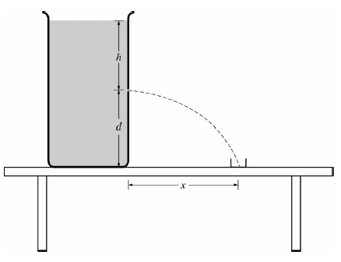
4. (10 points)

The large container shown in the cross section above is filled with a liquid of density
1.1x10³ kg/m³. A small hole of area 2.5x10⁻⁶ m² is opened in the side of the container a distance h below the liquid surface, which allows a stream of liquid to flow through the hole and into a beaker placed to the right of the container. At the same time, liquid is also added to the container at an appropriate rate so that h remains constant. The amount of liquid collected in the beaker in 2.0 minutes is 7.2x10⁻⁴ m³.

(a) Calculate the volume rate of flow of liquid from the hole in m³/ s.

(b) Calculate the speed of the liquid as it exits from the hole.

(c) Calculate the height h of liquid needed above the hole to cause the speed you determined in part (b).

(d) Suppose that there is now less liquid in the container so that the height h is reduced to 1/2 h . In relation to the beaker, where will the liquid hit the tabletop?

____ Left of the beaker ____ In the beaker ____ Right of the beaker

Justify your answer.

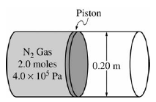
5. (10 points)
The figure above shows a 0.20 m diameter cylinder fitted with a frictionless piston, initially fixed in place. The cylinder contains 2.0 moles of nitrogen gas at an absolute pressure of 4.0x10⁵ Pa. Nitrogen gas has a molar mass of 28 g mole and it behaves as an ideal gas.

(a) Calculate the force that the nitrogen gas exerts on the piston.

(b) Calculate the volume of the gas if the temperature of the gas is 300 K.

(c) In a certain process, the piston is allowed to move, and the gas expands at constant pressure and pushes the piston out 0.15 m. Calculate how much work is done by the gas.

(d) Which of the following is true of the heat energy transferred to or from the gas, if any, in the process in part (c)?

_____ Heat is transferred to the gas.

_____ Heat is transferred from the gas.

_____ No heat is transferred in the process.

Justify your answer.

6. (10 points)
You are asked to experimentally determine the focal length of a converging lens.

(a) Your teacher first asks you to estimate the focal length by using a distant tree visible through the laboratory window. Explain how you will estimate the focal length.

To verify the value of the focal length, you are to measure several object distances s_{o} and image distances s_{i} using equipment that can be set up on a tabletop in the laboratory.

(b) In addition to the lens, which of the following equipment would you use to obtain the data?

____Lighted candle ____ Candleholder ____ Desk lamp ____ Plane mirror

____ Vernier caliper ____ Meterstick ____ Ruler ____ Lens holder

____ Stopwatch ____ Screen ____ Diffraction grating

(c) On the tabletop below, sketch the setup used to obtain the data, labeling the lens, the distances s_{o} and s_{i} and the equipment checked in part (b).

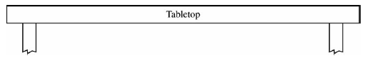

You are to determine the focal length using a linear graph of 1/s_{i} versus 1/s_{o}. Assume that you obtain the following data for object distance s_{o} and image distance s_{i}.

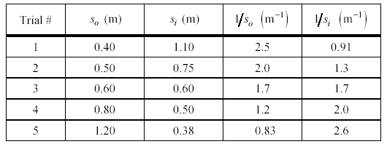

(d) On the grid below, plot the points in the last two columns of the table above and draw a best-fit line through the points.

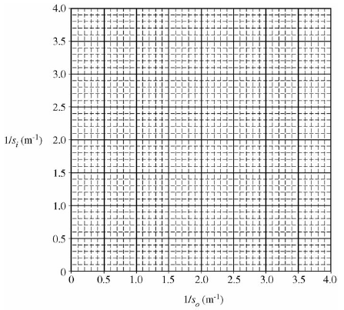

(e) Calculate the focal length from the best-fit line.

7. (10 points)
It is possible for an electron and a positron to orbit around their stationary center of mass until they annihilate each other, creating two photons of equal energy moving in opposite directions. A positron is a particle that has the same mass as an electron and equal but opposite charge. The amount of kinetic energy of the electron-positron pair before annihilation is negligible compared to the energy of the photons created.

(a) Calculate, in eV, the rest energy of a positron.

(b) Determine, in eV, the energy each emitted photon must have.

(c) Calculate the wavelength of each created photon.

(d) Calculate the magnitude of the momentum of each photon.

(e) Determine the total momentum of the two-photon system.

