2008 AP® PHYSICS B FREE-RESPONSE QUESTIONS

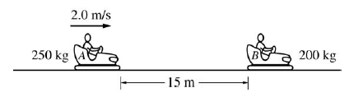
1. (10 points)
Several students are riding in bumper cars at an amusement park. The combined mass of car A and its occupants is 250 kg. The combined mass of car B and its occupants is 200 kg.
Car A is 15 m away from car B and moving to the right at 2.0 m/s, as shown, when the driver decides to bump into car B, which is at rest.
(a) Car A accelerates at 1.5 m/s² to a speed of 5.0 m/s and then continues at constant velocity until it strikes car B. Calculate the total time for car A to travel the 15 m.
(b) After the collision, car B moves to the right at a speed of 4.8 m/s.
i. Calculate the speed of car A after the collision.
ii. Indicate the direction of motion of car A after the collision.
____ To the left ____ To the right ____ None; car A is at rest.
(c) Is this an elastic collision?
____ Yes ____ No
Justify your answer.

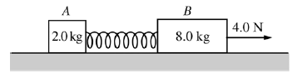

2. (15 points)
Block A of mass 2.0 kg and block B of mass 8.0 kg are connected as shown above by a spring of spring constant 80 N/m and negligible mass. The system is being pulled to the right across a horizontal frictionless surface by a horizontal force of 4.0 N, as shown, with both blocks experiencing equal constant acceleration.
(a) Calculate the force that the spring exerts on the 2.0 kg block.
(b) Calculate the extension of the spring.
The system is now pulled to the left, as shown below, with both blocks again experiencing equal constant acceleration.
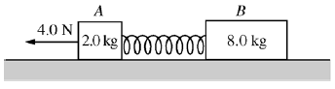

(c) Is the magnitude of the acceleration greater than, less than, or the same as before?
____ Greater ____ Less ____ The same
Justify your answer.

(d) Is the amount the spring has stretched greater than, less than, or the same as before?
____ Greater ____ Less ____ The same
Justify your answer.
(e) In a new situation, the blocks and spring are moving together at a constant speed of 0.50 m/s to the left. Block A then hits and sticks to a wall. Calculate the maximum compression of the spring.

3. (15 points)
A rectangular wire loop is connected across a power supply with an internal resistance of 0.50 Ω and an emf of 16 V. The wire has resistivity 1.7x10⁻⁸ Ω.m and cross-sectional area 3.5x10⁻⁹ m². When the power supply is turned on, the current in the wire is 4.0 A.
(a) Calculate the length of wire used to make the loop.

The wire loop is then used in an experiment to measure the strength of the magnetic field between the poles of a magnet. The magnet is placed on a digital balance, and the wire loop is held fixed between the poles of the magnet, as shown below. The 0.020 m long horizontal segment of the loop is midway between the poles and perpendicular to the direction of the magnetic field. The power supply in the loop is turned on, so that the 4.0 A current is in the direction shown.
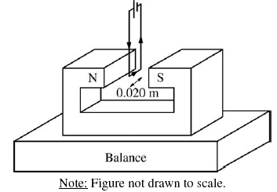

(b) In which direction is the force on the magnet due to the current in the wire segment?
____Upward ____Downward
Justify your answer.
(c) The reading on the balance changed by 0.060 N when the power supply was turned on. Calculate the strength of the magnetic field.

Suppose that various rectangular loops with the same total length of wire as found in part (a) were constructed such that the lengths of the horizontal segments of the wire loops varied between 0.02 m and 0.10 m. The horizontal segment of each loop was always centered between the poles, and the current in each loop was always 4.0 A. The following graph represents the theoretical relationship between the magnitude of the force on the magnet and the length of the wire.
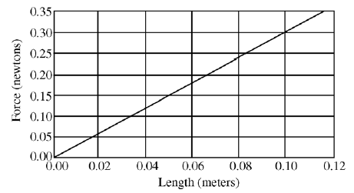

(d) On the graph above, sketch a possible relationship between the magnitude of the force on the magnet and the length of the wire segment if the wire segments were misaligned and placed at a constant nonperpendicular angle to the magnetic field, as shown below:
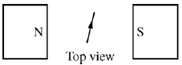

(e) Suppose the loops are correctly placed perpendicular to the field and the following data are obtained. Describe a likely cause of the discrepancy between the data and the theoretical relationship.
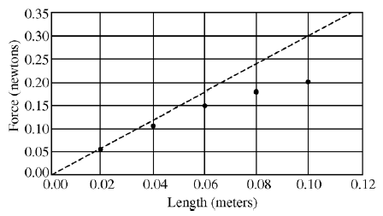

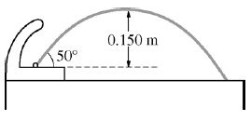

4. (10 points)
A drinking fountain projects water at an initial angle of 50° above the horizontal, and the water reaches a maximum height of 0.150 m above the point of exit. Assume air resistance is negligible.
(a) Calculate the speed at which the water leaves the fountain.
(b) The radius of the fountain’s exit hole is 4x10⁻³ m². Calculate the volume rate of flow of the water.
(c) The fountain is fed by a pipe that at one point has a radius of 7.00x10⁻³ m² and is 3.00 m below the fountain’s opening. The density of water is 1.0x10³ kg/m³. Calculate the gauge pressure in the feeder pipe at this point.

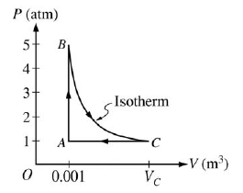
5. (10 points)
A 0.03 mol sample of helium is taken through the cycle shown in the diagram above. The temperature of state A is 400 K.
(a) For each process in this cycle, indicate in the table below whether the quantities W, Q, and ΔU are positive (+), negative (-), or zero (0). W is the work done on the helium sample.

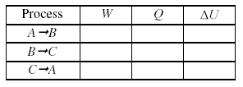

(b) Explain your response for the signs of the quantities for process .
(c) Calculate V_{C}.
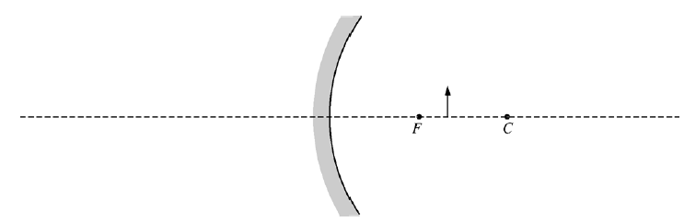

6. (10 points)
The figure above shows a converging mirror, its focal point F, its center of curvature C, and an object represented by the solid arrow.
(a) On the figure above, draw a ray diagram showing at least two incident rays and the image formed by them.
(b) Is the image real or virtual?
____ Real ____ Virtual
Justify your answer.
(c) The focal length of this mirror is 6.0 cm, and the object is located 8.0 cm away from the mirror. Calculate the position of the image formed by the mirror. (Do NOT simply measure your ray diagram.)
(d) Suppose that the converging mirror is replaced by a diverging mirror with the same radius of curvature that is the same distance from the object, as shown below.

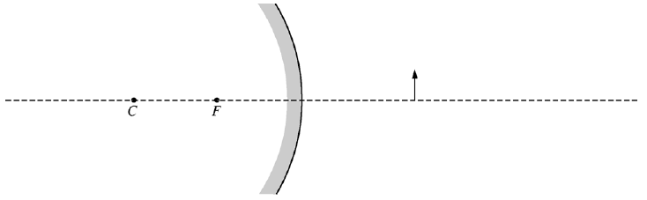

For this mirror, how does the size of the image compare with that of the object?
____ Larger than the object ____ Smaller than the object ____ The same size as the object
Justify your answer.

7. (10 points)
In an electron microscope, a tungsten cathode with work function 4.5 eV is heated to release electrons that are then initially at rest just outside the cathode. The electrons are accelerated by a potential difference to create a beam of electrons with a de Broglie wavelength of 0.038 nm. Assume non-relativistic equations apply to the motion of the electrons.
(a) Calculate the momentum of an electron in the beam, in kg m/s
(b) Calculate the kinetic energy of an electron in the beam, in joules.
(c) Calculate the accelerating voltage.
(d) Suppose that light, instead of heat, is used to release the electrons from the cathode. What minimum frequency of light is needed to accomplish this?

