Name_________________________________ Date: ______________Period_________

Activity 1: Pencil Electrolysis of Water

Water is often considered to be a rather stable compound; that is, adding energy in the form of heat only causes a change in its state, but the steam that results is still H2O. Nevertheless, you can use household materials to decompose water into its elements!

Procedures: | Observations:
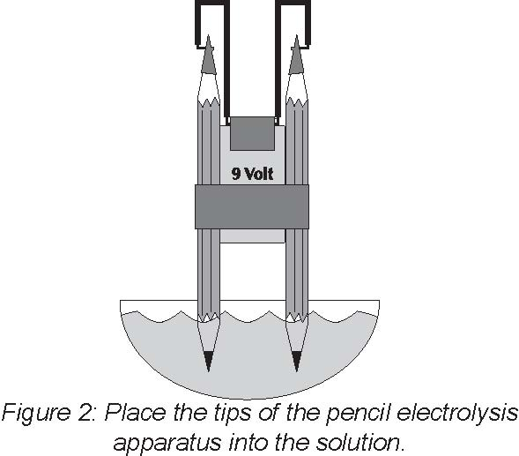  1. Fill a 250 mL beaker with about 50 mL of water. Obtain a pencil electrolysis apparatus from your teacher and place it into the beaker of water. | After 1 minute, look at the tips of the pencils. Write down what you observe at each tip.
2. Remove the pencil electrolysis apparatus and place on your lab desk. Come up to teacher’s desk and stir in half a spoonful of table salt to the beaker of water. Go back to your lab desk and place the pencil electrolysis apparatus in the beaker of salt water. | Look at the tips of the pencils. Write down what you observe at each tip.
3. Remove the pencil apparatus and place on your desk. Empty the beaker of salt water and rinse out the beaker. Once again, add 50 mL of water to the beaker. | What is the formula for water?
4. Bring the beaker of water up to your teacher’s desk. Add two drops of phenolphthalein solution to the beaker of water. Go back to your lab desk and place the pencil electrolysis apparatus in the beaker.  Phenolphthalein is an acid base indicator. It is colorless in an acid, and turns purple with a base. | Look at the tips of the pencils. Write down that you observe at each tip.

QUESTIONS: (answer in complete sentences)
- What is the formula for water, hydrogen gas, and oxygen gas?

- What does electrolysis mean?

- What does phenolphthalein do?

- What color is phenolphthalein when it is in an acidic solution?

- What color is phenolphthalein when it is in a basic solution?

- Bubbles formed at both pencil tips. However, what did you notice about the amount of bubbles that formed at each of the pencil tips?

- Pure water, H₂O, doesn’t conduct electricity, what was added to allow the solution to conduct electricity?

- Write the balanced equation for the decomposition of water.

