Name:______________________________________ Date:______________
Chemistry-2 Period_______________
Chapter 2 Activity 2: “States of Matter: Solid, Liquid, Gas”
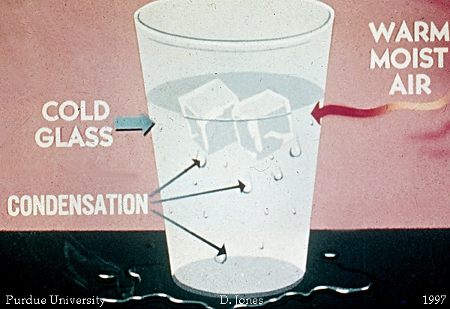
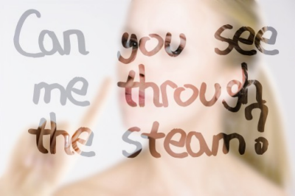

Procedures | Observations
1. Obtain a mirror from your teacher.  Hold it by the handle and Do Not touch the glass.  If you break the mirror you will have  7 years of bad luck and have to pay me $2.00 | Write two observations about the mirror.
2. Hold the mirror close to your mouth and exhale on the mirror.  Don’t worry I clean it between classes. | What happens when you exhale on the mirror?
3. Give the mirror back to your teacher so it can be put in the freezer for a few minutes. | Write two observations about the mirror after it comes out of the freezer.
4. Hold the mirror close to your mouth and exhale on the mirror.  Don’t worry, you’ll get the same mirror back. | What happens when you exhale on the mirror?
5. Using your finger, write a word on the fogged up mirror.  Don’t be vulgar!! | What word did you write?
6. Carefully set the mirror down and leave it alone for 5 minutes.  Do NOT wipe your mirror clean. | What do you observe?
7. Bring your mirror up to your teacher. It will be placed back in the freezer for a few minutes.  Start answering the questions below as you wait  . | What is happening to the mirror as it sits in the freezer?
8. Obtain a different mirror that has just been removed from the freezer. Hold it close to your mouth and exhale on the mirror. | What do you observe?
9. Bring the mirror up to your teacher. Place it flat on the teacher’s desk. Spray some glass cleaner on it and clean it with a paper towel. | Mirror, mirror on the wall, who is the fairest one of all?
Answer the following questions in COMPLETE sentences (when necessary):
- What is the definition of condensation?

- Condensation is a phase change. Is energy lost or gained when something condenses?

- Why did the mirror from the freezer fog up when you exhaled on it?

- Name two places where you have seen condensation occur.

- How could you use the principal of condensation as a special effect?

- What are three chemistry principals of condensation?

