Name:_____________________________________________ Date:____________________
Chemistry-2 Period_________________________

Chapter 2 Activity 2 “Heating Curves

Answer the following questions

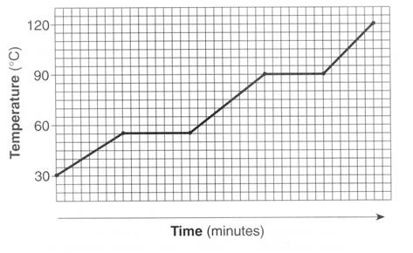
1. The graph below represents the heating curve of a substance that starts as a solid below its freezing point.

- What is the melting point of this substance? ______________
- What is the freezing point of this substance?______________
- What is the boiling point of this substance?_______________
- The liquid phase of this substance exists between what temperatures?__________ and _____________
- Is this substance water?_________________ How can you tell, explain below:

- Add the following to the chart below (use the arrows to show the direction)
  - Melting b. Freezing c. Deposition d. Vaporization
- Sublimation f. Evaporation g. Condensation
