Name:__________________________________________ Date:____________________
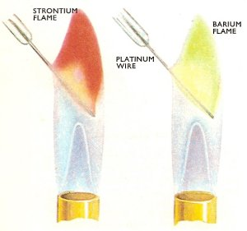
Chemistry Period________________

Activity 5: Electronic Behavior of Atoms

We have completed an activity teaching you about the electromagnetic spectrum. The electromagnetic spectrum is made up of energy. Energy can travel as waves (short wavelengths -gamma rays and long wavelengths-radio waves). In the electromagnetic spectrum, there is a very tiny region that we can see with our eyes. This region is visible light.

If you look up at the lights on the ceiling, what color(s) do you see?___________________________

Now put on the glasses and look up at the lights again. What color(s) do you see? __________________________________________________________________________________

Today you will see many many many colors.

FLAME TEST:

Element | Flame Description
Let’s Review the history of the atom:

Scientist Name | Draw  Atomic Model

Label and draw Bohr’s contribution to the evolution of the atomic model?

