Name:__________________________Date:_____________________Period________________
Chapter 2 Activity 5 Measuring-Using a Ruler
Directions: Using both scales on the ruler provided by your teacher, measure the following lines.
 | Ruler Scale #1 | Ruler Scale #2
1. _________________________
2. ________________
3. ________________________________
4. ___________________________
5. ______________________
6. ____________________________________
7. ________
8. _____________
9. _________________________________________
10. ___
Chapter 2 Activity 5 Measuring-Using a Four Beam Balance
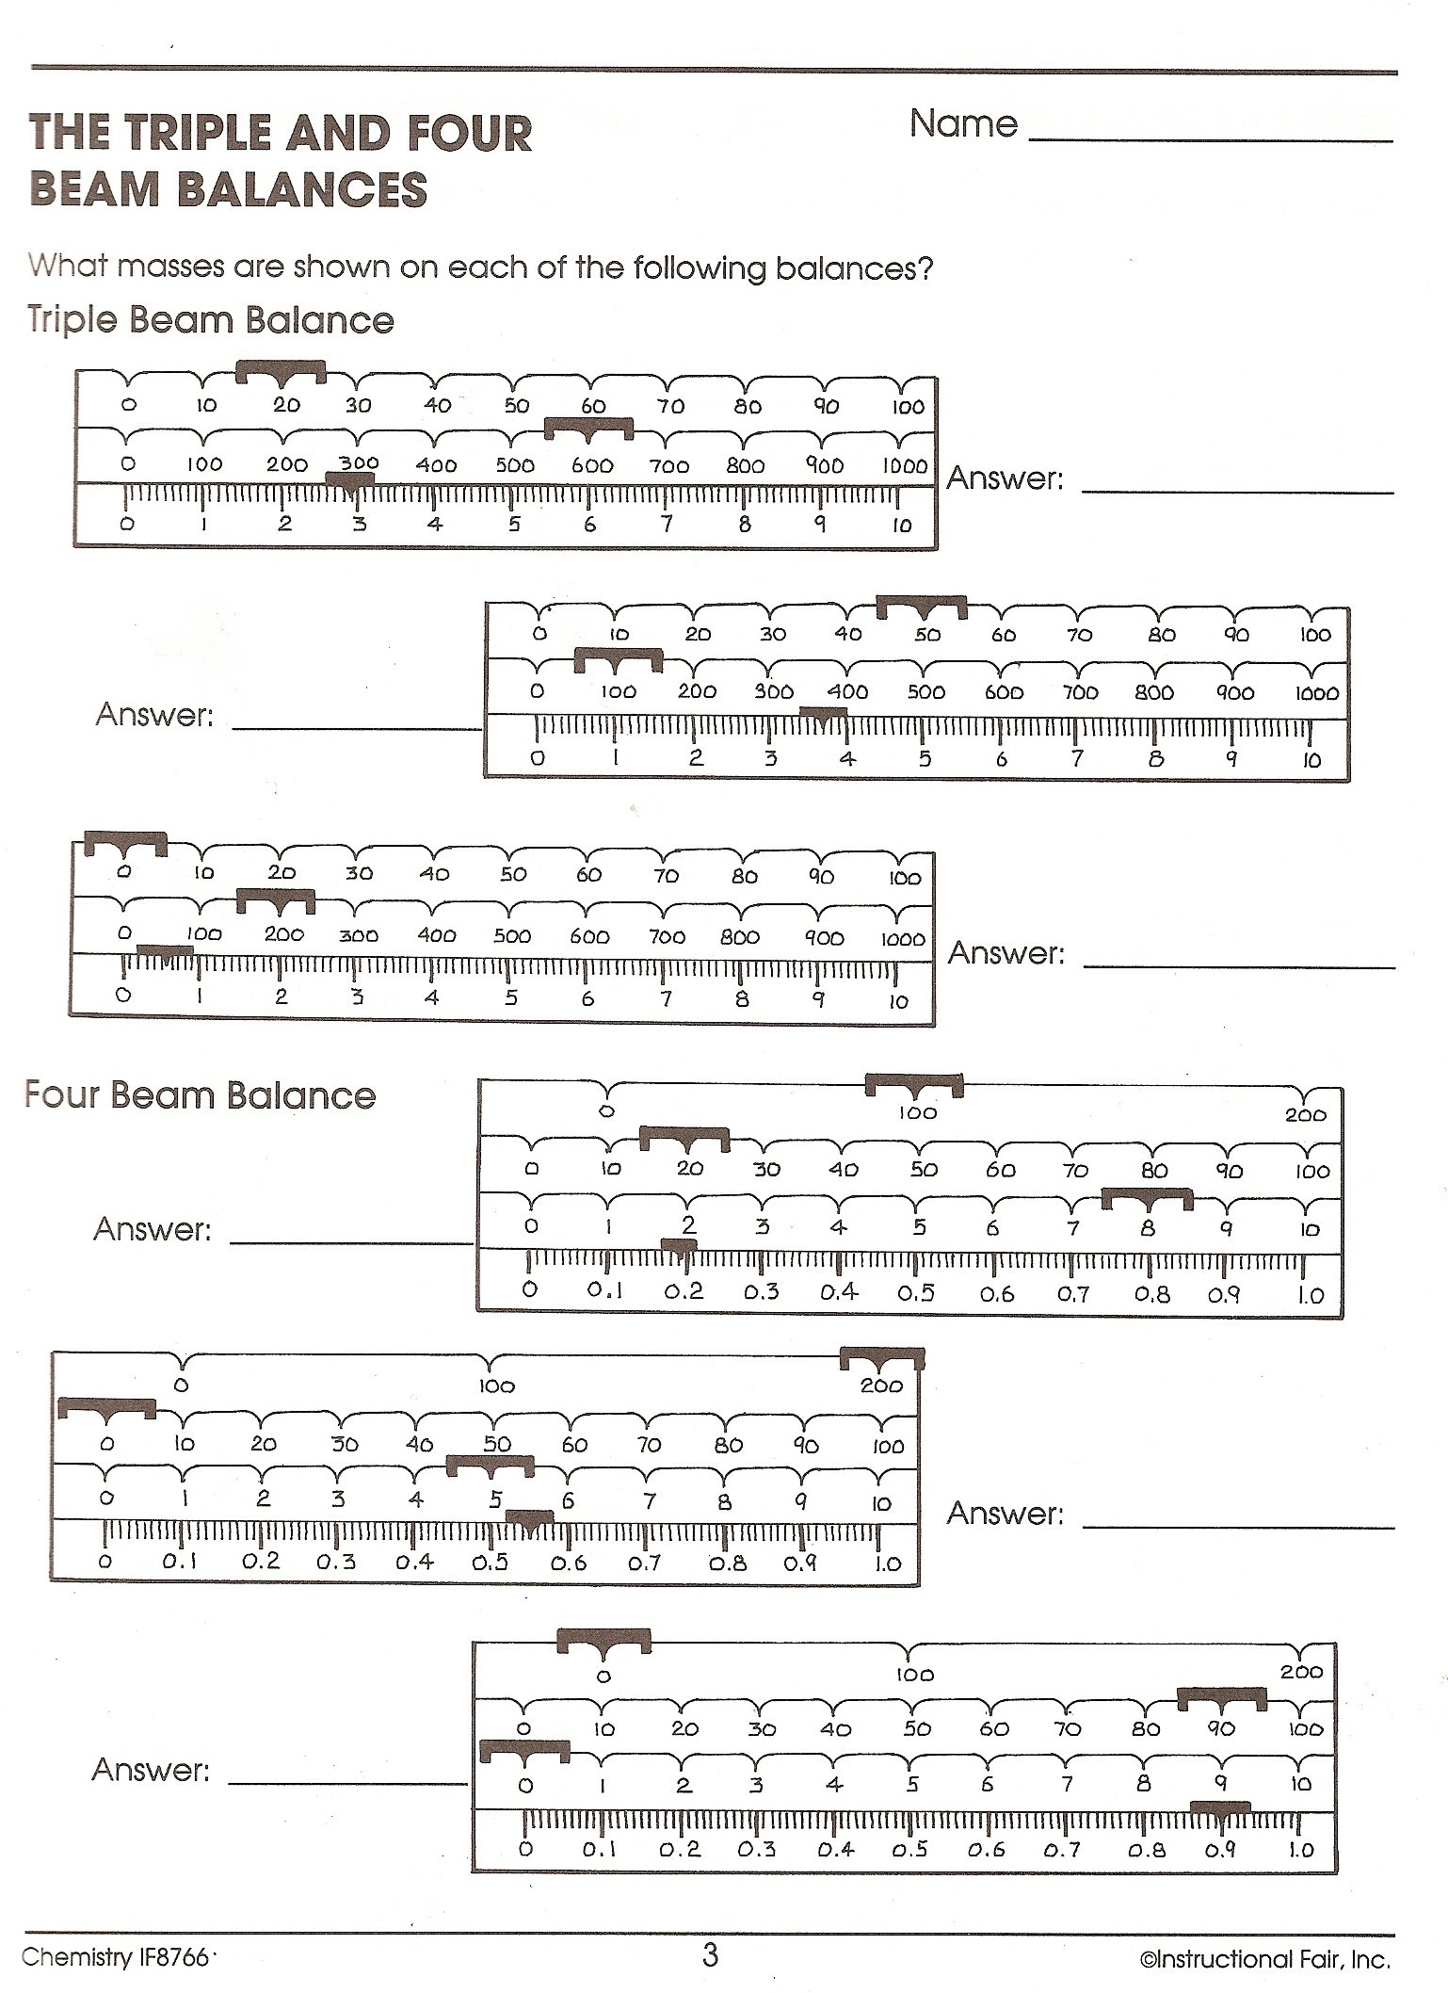
Directions: Using the riders shown, read the balances and determine what mass is represented.

Name:__________________________Date:_____________________Period________________
Chapter 2 Activity 5 Measuring-Using a Graduated Cylinder
Directions: Read the meniscus and record the correct measurement
"A characteristic of liquids in glass containers is that they curve at the edges. This curvature is called the meniscus. You measure the level at the horizontal center or inside part of the meniscus. With water in glass, the meniscus will curve up at the edges and down in the center so we say you read the bottom of the meniscus."
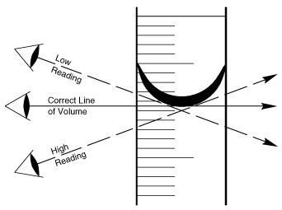
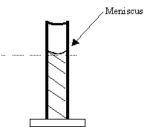
When measuring liquid volume it is important to read the graduated cylinder correctly. You eye should be level with the top of the liquid and you should read the bottom of the meniscus.

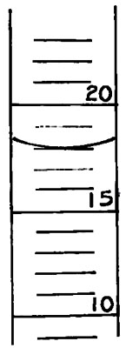
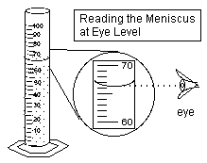
1. _______ 2. __________

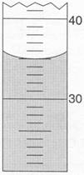
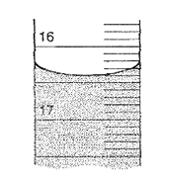
3. _________ 4. ___________
15

