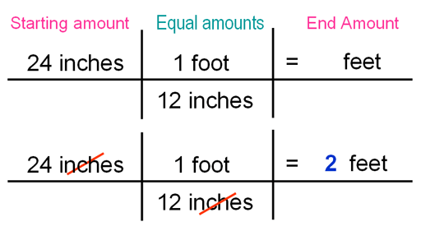
Name:__________________________Date:_____________________Period________________
Chapter 2 Activity 5 Unit Conversions

We Are Learning____________________________________________________

Directions: Use the following conversion factors to assist you with the problems below. Show all work and circle your final answer.
English System | Metric System | English System | Metric System
Units of Distance |  | Units of Volume
12 in = 1 ft | 10 mm = 1 cm | 3 tsp = 1 tbsp | 1 cm³ = 1 ml
3 ft = 1 yd | 100 cm = 1 m | 8 oz = 1 c | 1000 mL = 1 L
1760 yds = 1 mi | 1000m = 1 km | 2 c = 1 pt | 1000L = 1m³
5280 ft = 1 mi |  | 2 pt = 1 qt
1 in = 2.54 cm |  | 4 qt = 1 gal
1 mile = 1.61 km |  | 3.70 L = 1 gal
English System | Metric System | English System | Metric System
Units of Mass |  | Units of Time
16 oz = 1 lb | 1000 mg = 1 g | 60 sec = 1 min | 1 sec = 1000 msec
2000 lb = 1 ton | 1000 g = 1 kg | 60 min = 1 hr
453 g = 1 lb |  | 24 hr = 1 day
2.2 lb = 1 kg |  | 7 days = 1 wk
 |  | 52 wk = 1 yr
- 74 cm = ? in
74 cm

x
=

- 5.5 yd = ? ft

- 1.2 mi = ? ft

- 4.3 m = ? cm

- 25.6 mm = ? cm

- 2,076 mm = ? m

- 4.2 lb = ? oz
- 50 kg = ? lb

- 2.5 ton = ? oz

- 7 tbsp = ? tsp

- 4 c = ? pt

- 5 gal = ? qt

- 4 gal = ? cups

- 5 ml = ? cm³

- 6.5 ml = ? L

- 4 min = ? sec

- 5 days = ? hr

- 2.5 yr = ? wk

- 17 yr = ? sec

