Name:_________________________________ Date:____________________

Chemistry Period________________

We are learning________________________________________

Activity 5: Electronic Behavior of Atoms

Sun tanning is when your skin is exposed to the sun’s ultraviolet radiation for the purpose of darkening your skin color.

This can be done either during sun bathing or using artificial light sources such as tanning beds.

Excessive exposure to ultraviolet rays has detrimental health effects, including skin burns, cataracts, and skin cancer.
Energy inc/frequency inc/wavelength dec →

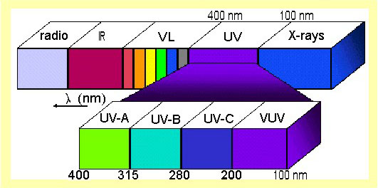

Use the diagram above to answer the following questions.

1. Is UV light more or less energetic than visible light? ________________________________

Ultraviolet rays can be subdivided into four different spectrums, UV-A, UV-B, UV-C, and Vacuum UV.

2. Out of the UV-A, UV-B, and UV-C rays, which one is most energetic?_______________________

- Would these rays have long or short wavelengths?____________________________


UV-C is most energetic and most harmful; UV-A is least energetic and least harmful.

Luckily, UV-C rays do not reach the earth’s surface because of the ozone layer.

Therefore, no UV-C rays from the sun ever come into contact with life on earth, but
man-produced UV-C rays can be a hazard in certain professions, such as welders
(that is why welders wear those masks to prevents welders’ flash).

UV-C is also used for sterilization (this is how we disinfect your lab goggles), and water purification.
UV-B rays have a lower energy level and a longer wavelength than UV-C.

Some of them extend down to the earth's surface and can be detrimental to our health. UV-B rays are used in tanning beds. They have been known to cause premature skin aging, sun burns, cataracts, and skin cancer.

Humans do need some exposure to UV-B rays because it helps our bodies produce vitamin D.

3. UV-B rays can not penetrate glass. Will you get a sunburn if you are sitting in your car with the
windows up on a sunny day?_____________________________

UV-A rays pass through the earth's atmosphere almost unfiltered. Tanning booths primarily use UV-A. It is also used in black lights and insect control lamps. Less likely than UV-B to cause sun burns. It causes wrinkling and skin leathering.

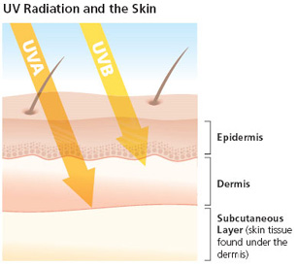
4. Look at the picture to the right, which type of UV
radiation penetrates the skin deeper?_______________

Did you know?
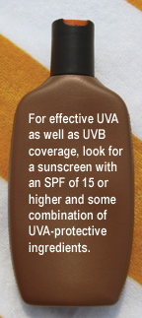
According to recent research, first exposure to tanning beds in youth increases melanoma (skin cancer) risk by 75 percent.

As both UV-B and UV-A rays can be detrimental to our health, it is important that we protect ourselves.

This can be done through a variety of ways.

The most obvious is to reduce the amount of time one spends in the sun, particularly between the hours of 11 am and 3 pm, when the sun is at its highest in the sky.

Another way to protect ourselves is to use a broad-spectrum sunblock and not sunscreen.

5. Can you promise me to never go to a tanning salon?__________________

