Name:__________________________________________ Date:____________________

Period________________ Lumsden/Pittenger/Jurgrau
Activity 6: Atoms with More than One Electron

Directions: Answer the following questions in complete sentences.

- What axis is the horizontal line?

- What is a way to remember which way is horizontal?

- What axis is the vertical line?

- What axis is the independent axis?

- What axis is the dependent axis?

- State some properties about the independent axis.

- State some properties about the dependent axis.

- Why is it important to always have units?

- What would be the title of the following graph?

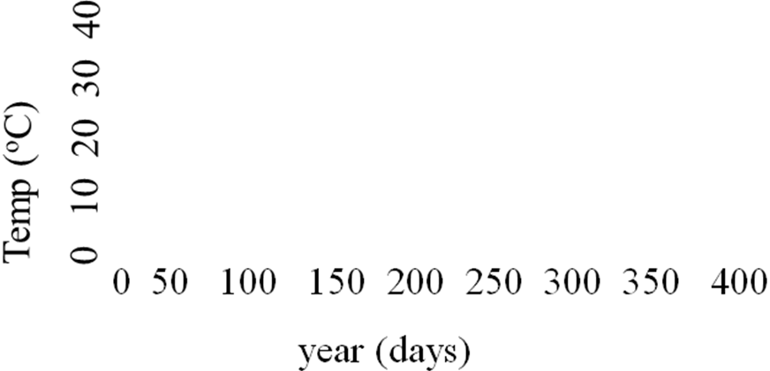

- Using the graph in Question #8, what is the scale of the y-axis?

- Using the graph in Question #8, what is the scale of the x-axis?

- What trend do we see when we graph atomic mass vs atomic number?

- Which graph shows the trend for atomic mass vs atomic number?

A B C

- What happens to the size of atoms as we move down a group on the periodic table?

- Define ionization energy:

- Is it easier or harder to remove and electron that is far away from the nucleus?
Explain why.

- What trend do we see when we graph ionization energy vs atomic number
(remember to talk about group vs period)?

a. Group trend

b. Period trend

- Which graph shows the trend for ionization energy vs atomic number?

A B C

- Which atom has a higher ionization energy, Li or F? Why?

- Which atom has a higher ionization energy, Li or Fr? Why?

- Look at the picture below and explain what is happening.

- Using what you have learned from Activity 6, come up with 5 questions (and answers) that can be used for your game:

1.

2.

3.

4.

5.

