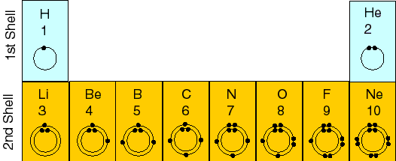
Name:________________________________________ Date:_________________________
Chemistry-2 Period___________________ Jurgrau/Lumsden/Pittenger

Chapter 1 Activity 7 “How Electrons Determine Chemical Behavior”

Element | Bohr Model (atom) | # of Valence Electrons | Subatomic  Particles |  | Is it an Atom? | Does it have an octet or duet (small atoms)? | Remove or add e^{-s} to become stable | Subatomic  Particles  (for ion) |  | New Bohr Model (ion)
 |  |  | p⁺ | e⁻ | yes/no | yes/no | remove or add | p⁺ | e⁻
₁H | ₁H )  1 | 1 | 1 | 1 | yes | No | Add 1 e⁻ | 1 | 2 | ₁H ) ⁻¹  2
₃Li
₄Be
₅B
₆C
₇N
₈O
₉F
₁₀Ne
Atoms | Ions
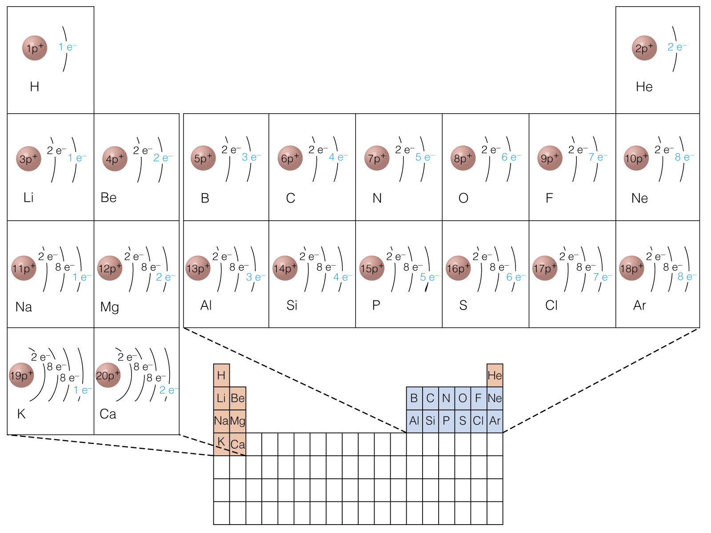

 | IA  1 | IIA  2 |  | IIIA  13 | IVA  14 | VA  15 | VIA  16 | VIIA  17 | VIIIA  18
Bohr Diagram | Li | Be |  | B | C | B | O | F | Ne
# Valence e^{-s}
Lose or Gain e^{-s}
Metal/ Nonmetal
Ionic Charge

