Name:__________________________Date:_____________________Period________________
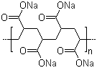
Chapter 2 Activity 7 “Fake Snow Polymer”
Introduction: You have been learning a lot about polymers. Polymers are long chains of smaller, repeating monomers that are bonded together. Some polymers have very interesting properties. These properties are due to the type of bonding within the polymer strands. Today we are going to learn about a polymer called sodium polyacrylate. The bonding within the sodium polyacrylate polymer gives it the ability to absorb many times its weight in water. You will analyze some of the properties of this polymer in this activity.
Procedure: | Observations in sentence form
1.Bring a small beaker from your lab drawer up to your teacher to get a sample of the sodium polyacrylate polymer. | How much of the polymer do you have?  Describe what you see in the beaker.
2. In a separate beaker, add 150 ml of water. Pour the water into the beaker with the sodium polyacrylate. | What happens?  How long did it take?
3.Touch the sodium polyacrylate with your fingers. DO NOT put it near your face. | How does it feel? What is strange about it?  Does it feel hot or cold?
4.Take a 400 ml beaker from your lab drawer. Fill it 1/4 of the way with the sodium polyacrylate-water mixture. Add another 100 ml of water. | What do you notice?  How is the sodium polyacrylate different?
5.Continue adding water to the sodium polyacrylate mixture until the beaker is almost full. | How has the sodium polyacrylate changed?
6.Get some table salt from your teacher and sprinkle the salt into the beaker so that it coats the top layer of sodium polyacrylate. Watch closely!! | What do you notice happening?
7.The sodium polyacrylate should be disposed of into the bucket at the teacher’s desk. DO NOT ALLOW IT TO GO DOWN THE DRAIN! All glassware should be thoroughly cleaned and put away.
Think About It:
1. Why is the sodium polyacrylate polymer referred to as the “fake snow polymer?”

2. As more water was added to the sodium polyacrylate, the texture of it changed. Give an explanation as to why this change occurred.

3. The diagram to the right shows two repeating monomer units of the sodium polyacrylate polymer chain before it has been exposed to water. Circle one of the monomer units.

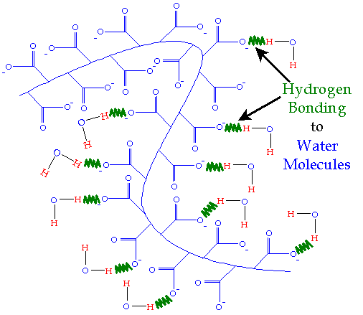
4. a.The diagram to the right shows the sodium polyacrylate polymer chain after it has been exposed to water. How is it different than the diagram in question #3 above?

b. Refer back to step 6 in the activity where table salt (Sodium chloride, NaCl) is added to the sodium polyacrylate. Based on your observations of what happened AND your analysis of the diagrams in questions 3 and 4a above, explain why the salt would have brought about such a change.

5. How can this substance be used as a special effect in your movie scene?

