Name:________________________________________________ Date:_____________

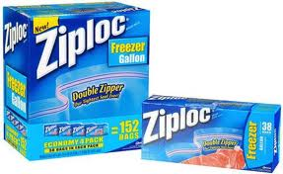
Chemistry-2 Period____________

Chapter 1 Activity 3: Chemistry in a Bag (20 points)

We are learning_________________________________________________________

Procedures | Observations
1. Obtain a Ziploc bag from your teacher's desk
2. At your teacher's desk, put one spoonful of baking soda (sodium bicarbonate-NaHCO₃) in the bag. Go back to your lab station to observe the substance. | Describe three physical properties of the NaHCO₃.
3. At your teacher's desk, obtain two spoonfuls of calcium chloride (CaCl₂) in a small cup. Go back to your lab station and observe the substance. Once you have made your observations, pour the CaCl₂ into the bag. | Describe three physical properties of the CaCl₂.  When you mixed the two substances, was this a physical or chemical change?  How do you know?
4. Take the small cup back to your teacher's desk and add 10 drops of bromothymol blue indicator solution. Go back to your lab station and using a graduated cylinder at your lab station, measure 10 ml of water and pour it into the cup. | Describe three physical properties of the bromothymol blue.
5. Place the small cup UPRIGHT inside the Ziploc bag, squeeze all the air out of the bag, and seal the bag carefully. **Make sure the bromothymol blue and water mixture does NOT spill into the bag! Make sure your bag is completely sealed!!!! | 
6. Carefully invert the cup and mix the bromothymol blue and water mixture with the CaCl₂ and NaHCO₃ inside the bag.  DO NOT OPEN THE BAG!!!!! | What do you observe happening?All lines must be filled in!  1._____________________________________________  2._____________________________________________  3._____________________________________________  4._____________________________________________  Should the mass of the sealed bag and its contents change after the reaction finishes? _________(Yes or No)  Why do you think so?  What law explains your answer above?  Define the law in the space below:
7. One of the most obvious changes inside the bag is the formation of a gas.  You will now test a chemical property of this gas to see if it can react with the oxygen in the air to burn. Read through all of the instructions that follow BEFORE you perform any of the steps.  You only have ONE chance to do it correctly.  Get a wood splint and a lighter from your teacher. Light the end of the wood splint. Have your partner gently open the bag. Immediately as your partner opens one end of the bag, hold the lit end of the splint into the opening of the bag, but DO NOT let go of the splint. | How do you know a gas formed inside the bag?  Why do you only have one chance to do this part correctly?  What happened to the lit splint  once it was exposed to the gas in  the bag?  
8. Take the entire bag (contents and cup) and dispose of it in the garbage.

Questions: (answer in complete sentences)

1. State one physical change that occurred during this activity. (2 pts)

2. State three things that you observed that provides EVIDENCE that a chemical change took place during this activity. (3pts)

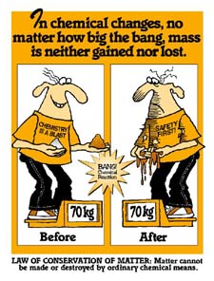
3. Explain how the Law of Conservation of Matter applies to the cartoon at the right. (3 pts)

4. Refer to step 7 above. The equation below represents what chemical reaction took place inside your bag. Circle the substance in the equation below that was responsible for what you observed happen to the flame. (1 pt)
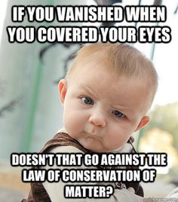
2NaHCO₃ + CaCl₂ → CaCO₃ + 2NaCl + CO₂ + H₂O

What lead you to this conclusion? (2 pts)

