Lab: % Composition

Students: Please read the following information given below, and then come to class on your lab day with the following already prepared in your notebooks:

1) Date, 2) Partner, 3) Title, 4) Purpose, 5) Materials, 6) Safety, 7) Diagram,
8) Procedures/Observations, and 9) Data/Calculations (collect data in your notebooks).

In this lab, you will be required to make up your own data/calculations table. Read the steps carefully to see what data should be collected. Be sure to make a neat and organized data table in your notebooks, and later, rewrite it in the Data and Calculations section on page 2. Questions on the last page need to be printed out and will be done after completion of the experiment. These questions and the data and calculations will be due one week after performing the lab in class (your next lab class). No formal lab report is necessary.

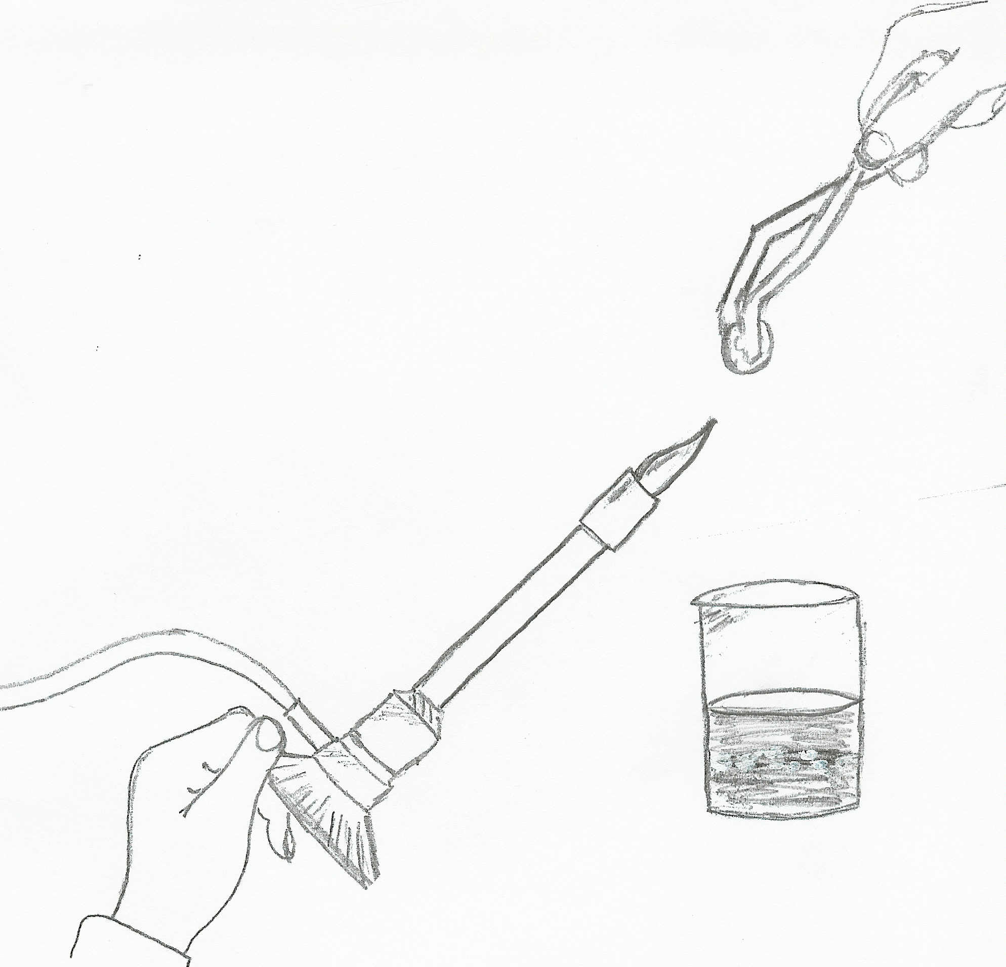
In a previous lab, Density, it was discovered that certain pennies are composed of more than just copper. In this lab, a post-1982 penny will be melted and the metals that it is composed of will be collected. Therefore, on lab day, please bring a post-1982 penny.

Review picture at right

A 600 mL beaker should be filled halfway with water. The mass of the
post-1982 penny should be recorded. The post-1982 penny should be grasped with the tongs and heated in the hottest part of the flame. One lab partner should hold the burner at the base and another lab partner should hold the penny with the tongs.

Safety: Make sure your hands are not directly above the flame when holding the tongs! Remember to grasp bunsen burner at the base.

When heating the penny, it should be held over a beaker so that after
2-3 minutes (when the core starts to separate) the molten metal will drop into the water. It might be necessary to gently shake the penny as it melts to remove its molten core. Once separated, keep heating the penny skins for 5 minutes and observe and record. After the 5 minutes, the penny skins should also be dropped into the beaker and allowed to cool.

Safety: The tongs will be very hot! Do not touch any areas that were heated!

After a few minutes, remove the cooled penny skins and core from the beaker. Thoroughly dry them and determine the mass of the penny skins and the core. The percent composition of the zinc and copper in the penny should then be determined.

Compare the percent composition calculated in this lab to what should have been calculated, actual percentages of zinc and copper in a post-1982 penny (obtain information about actual percents from a reliable source and properly cite that source).

Disposal:
Pour the water down the drain. Either keep the penny skins and core or wrap them in paper before discarding them in the trash.

Name______________________________________ Date_____________
Period_________________ Lab Group #_______

Lab: % Composition
Data/Calculations: Draw your own table below, enter in data, calculate % composition, and then
calculate % error.

Questions: Answer in complete sentences and properly cite references used.

1. Why does the core of the penny melt but the outside skins do not. Explain thoroughly.

2. What observations were made about the flame when heating the penny skins during this lab? When was this
previously observed? Explain thoroughly.

3. Would this lab work to determine percent composition for a pre-1982 penny? Explain thoroughly.

