LAB: SPECIFIC HEAT (this is a typed up lab report)

Students: Please read the following information given below, and then come to class on your lab day with the following already prepared in your notebooks:

1) Date, 2) Partner, 3) Title, 4) Purpose, 5) Materials, 6) Safety, 7) Diagram
8) Procedures/Observations, and 9) Data Table 1 (collect data in your notebooks)

The last 2 pages need to be printed out. These pages will be turned in. Data for this lab should be collected in your notebooks and later, rewritten in the Data and Calculations section. The data, calculations, and questions will be due one week after performing the lab in class (your next lab class).
Figure 1

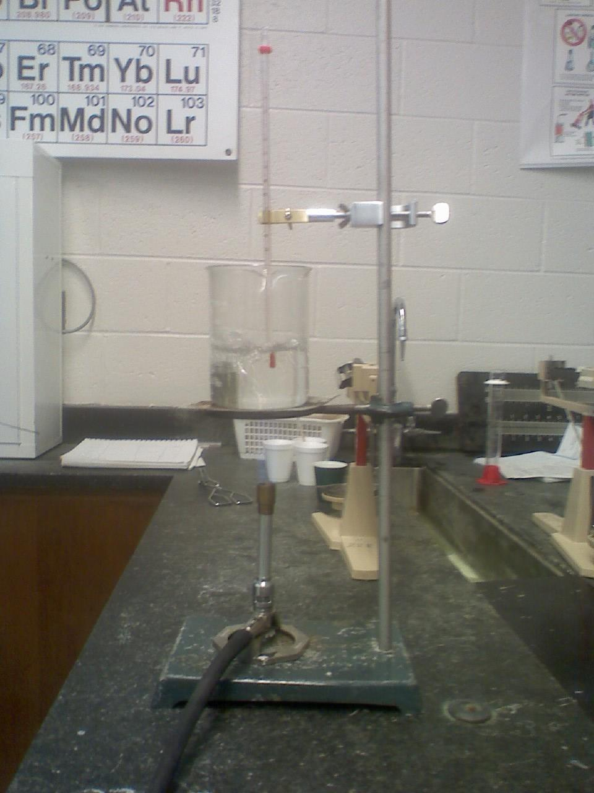
The typed up lab report is due one week after the completion of this lab.

The ringstand apparatus should be set up. Add a ringclamp along with wire gauze, and then put a Bunsen burner underneath. Attach a thermometer clamp above the beaker. See Figure 1

Approximately 350 mL of hot tap water (obtained from teacher sink) should be added to a beaker and heated using a bunsen burner until boiling. Obtain three styrofoam cups. 75 ml of room temperature water should be added to each cup, and then determine the mass of the water (1 mL = 1 gram) and the temperature of the water. Record in DATA TABLE 1.

Two metal samples and one unknown should be obtained from your instructor. Determine the mass of each metal. Record. Remember, the unknown will be one these 6 metals, Al, Cu, Fe, Pb, Cd, and Zn, and not necessarily one of the metals that was actually tested in this lab. Therefore, use the skills developed in this lab to identify the unknown.

Using tongs, place all three metals GENTLY into the beaker of boiling water. Let them sit in the boiling water
for 5 minutes. After 5 minutes, take the temperature of the water (place thermometer in the middle of the water bath). Then use the tongs to remove one of the metal samples and place immediately into one of the Styrofoam cup that contains the room temperature water. Do not leave the metal exposed to the air!
Record the new temperature of the water (metal in water).

This procedure should be repeated for the last two metal samples (one known and one unknown).

DATA TABLE 1: Copy table into your notebooks and record data in notebooks.
Remember to use proper significant figures and units
Metal Sample | 1. Identity ____________ | 2. Identity ____________ | 3. unknown __________
Mass of water
Mass of metal
Start temp. of water in cup
Start temp. of metal
Final temp. of water with metal in cup

Use the data that has been collected to complete the calculations on the following page.

Name_____________________________________ Date_____________
Period_________________ Lab Group #_______
Lab: SPECIFIC HEAT

CALCULATIONS: Remember to show all work for full credit. Rewrite the final answers on DATA TABLE 2:
 | Metal Sample | 1. Identity ______________ | 2. Identity______________ | 3. Unknown ____________
1. | Mass of water
2. | Temp. change  of water
3. | Gain of heat by water  (gain in water =  loss by metal)
4. | Temp. change  of metal
5. | Mass of metal
6. | Experimental Value  of Cp
7. | Actual Value  (cal/g ºC)
8. | Percent of Error
Name_____________________________________ Date_____________
Period_________________ Lab Group #_______
Lab: SPECIFIC HEAT

DATA TABLE 2: Final Answers. Remember to use proper significant figures and show units.
 | Metal Sample | Al | Cu | Fe | Pb | Cd | Zn | unknown
1. | Mass of water
2. | Temp. change of water
3. | Gain of heat by water  (gain in water = loss by metal)
4. | Temp. change of metal
5. | Mass of metal
6. | Experimental Value of Cp
7. | Actual Value (cal/g ºC) | .215 | 0.0931 | 0.111 | 0.0313 | 0.0561 | 0.0941
8. | Percent of Error

9. Explain the difference between the temperature change of the water and the temperature change of the
metal.

10. While Styrofoam is an excellent insulator, it is not 100% effective. Explain what would be the effect of a
small amount of heat being absorbed by the walls on the values determined by this experiment. Use some
of your measurements in your explanation.

