Lab: Types of Chemical Reactions
Safety is very important when combining chemicals

Students: Please read the following information given below, and then come to class on your lab day with the following already prepared in your notebooks:

1) Date, 2) Partner, 3) Title, 4) Purpose, 5) Materials, 6) Safety, 7) Diagram, and
8) Procedures/Observations 9) Printed copy of solubility chart

The questions need to be printed out. The questions will be done after completion of the experiment. These page(s) will be submitted along with the formal typed up lab report. The lab report is due one week after performing the lab in class (your next lab class). The solubility chart will assist you in answering the post lab questions.

Although countless chemical reactions exist, nearly all of them can be classified into a few specific categories. This experiment will allow one to differentiate the five general types of chemical reactions. Two different types of reactions will be performed, the others will be identified through chemical equations. From observations, identify the products of each reaction and determine the type of reaction that has taken place. Make sure the five general types of chemical reactions are known before beginning lab.

Experiment 1: Lead (II) Nitrate and Sodium Iodide
Be sure to follow all safety procedures for glassware, chemicals, etc.
Obtain two test tubes (one of Lead (II) Nitrate and the other of Sodium Iodide) from the teacher and place them in your test tube rack back at your lab station. Once both test tubes have been obtained, make observations of both test tubes. Finally, pour the Sodium Iodide into the Lead (II) Nitrate test tube and then record your observations immediately. Perform the next experiment, and at the end of Exp. 2, observe the test tube again. Record your observations.
Figure 1

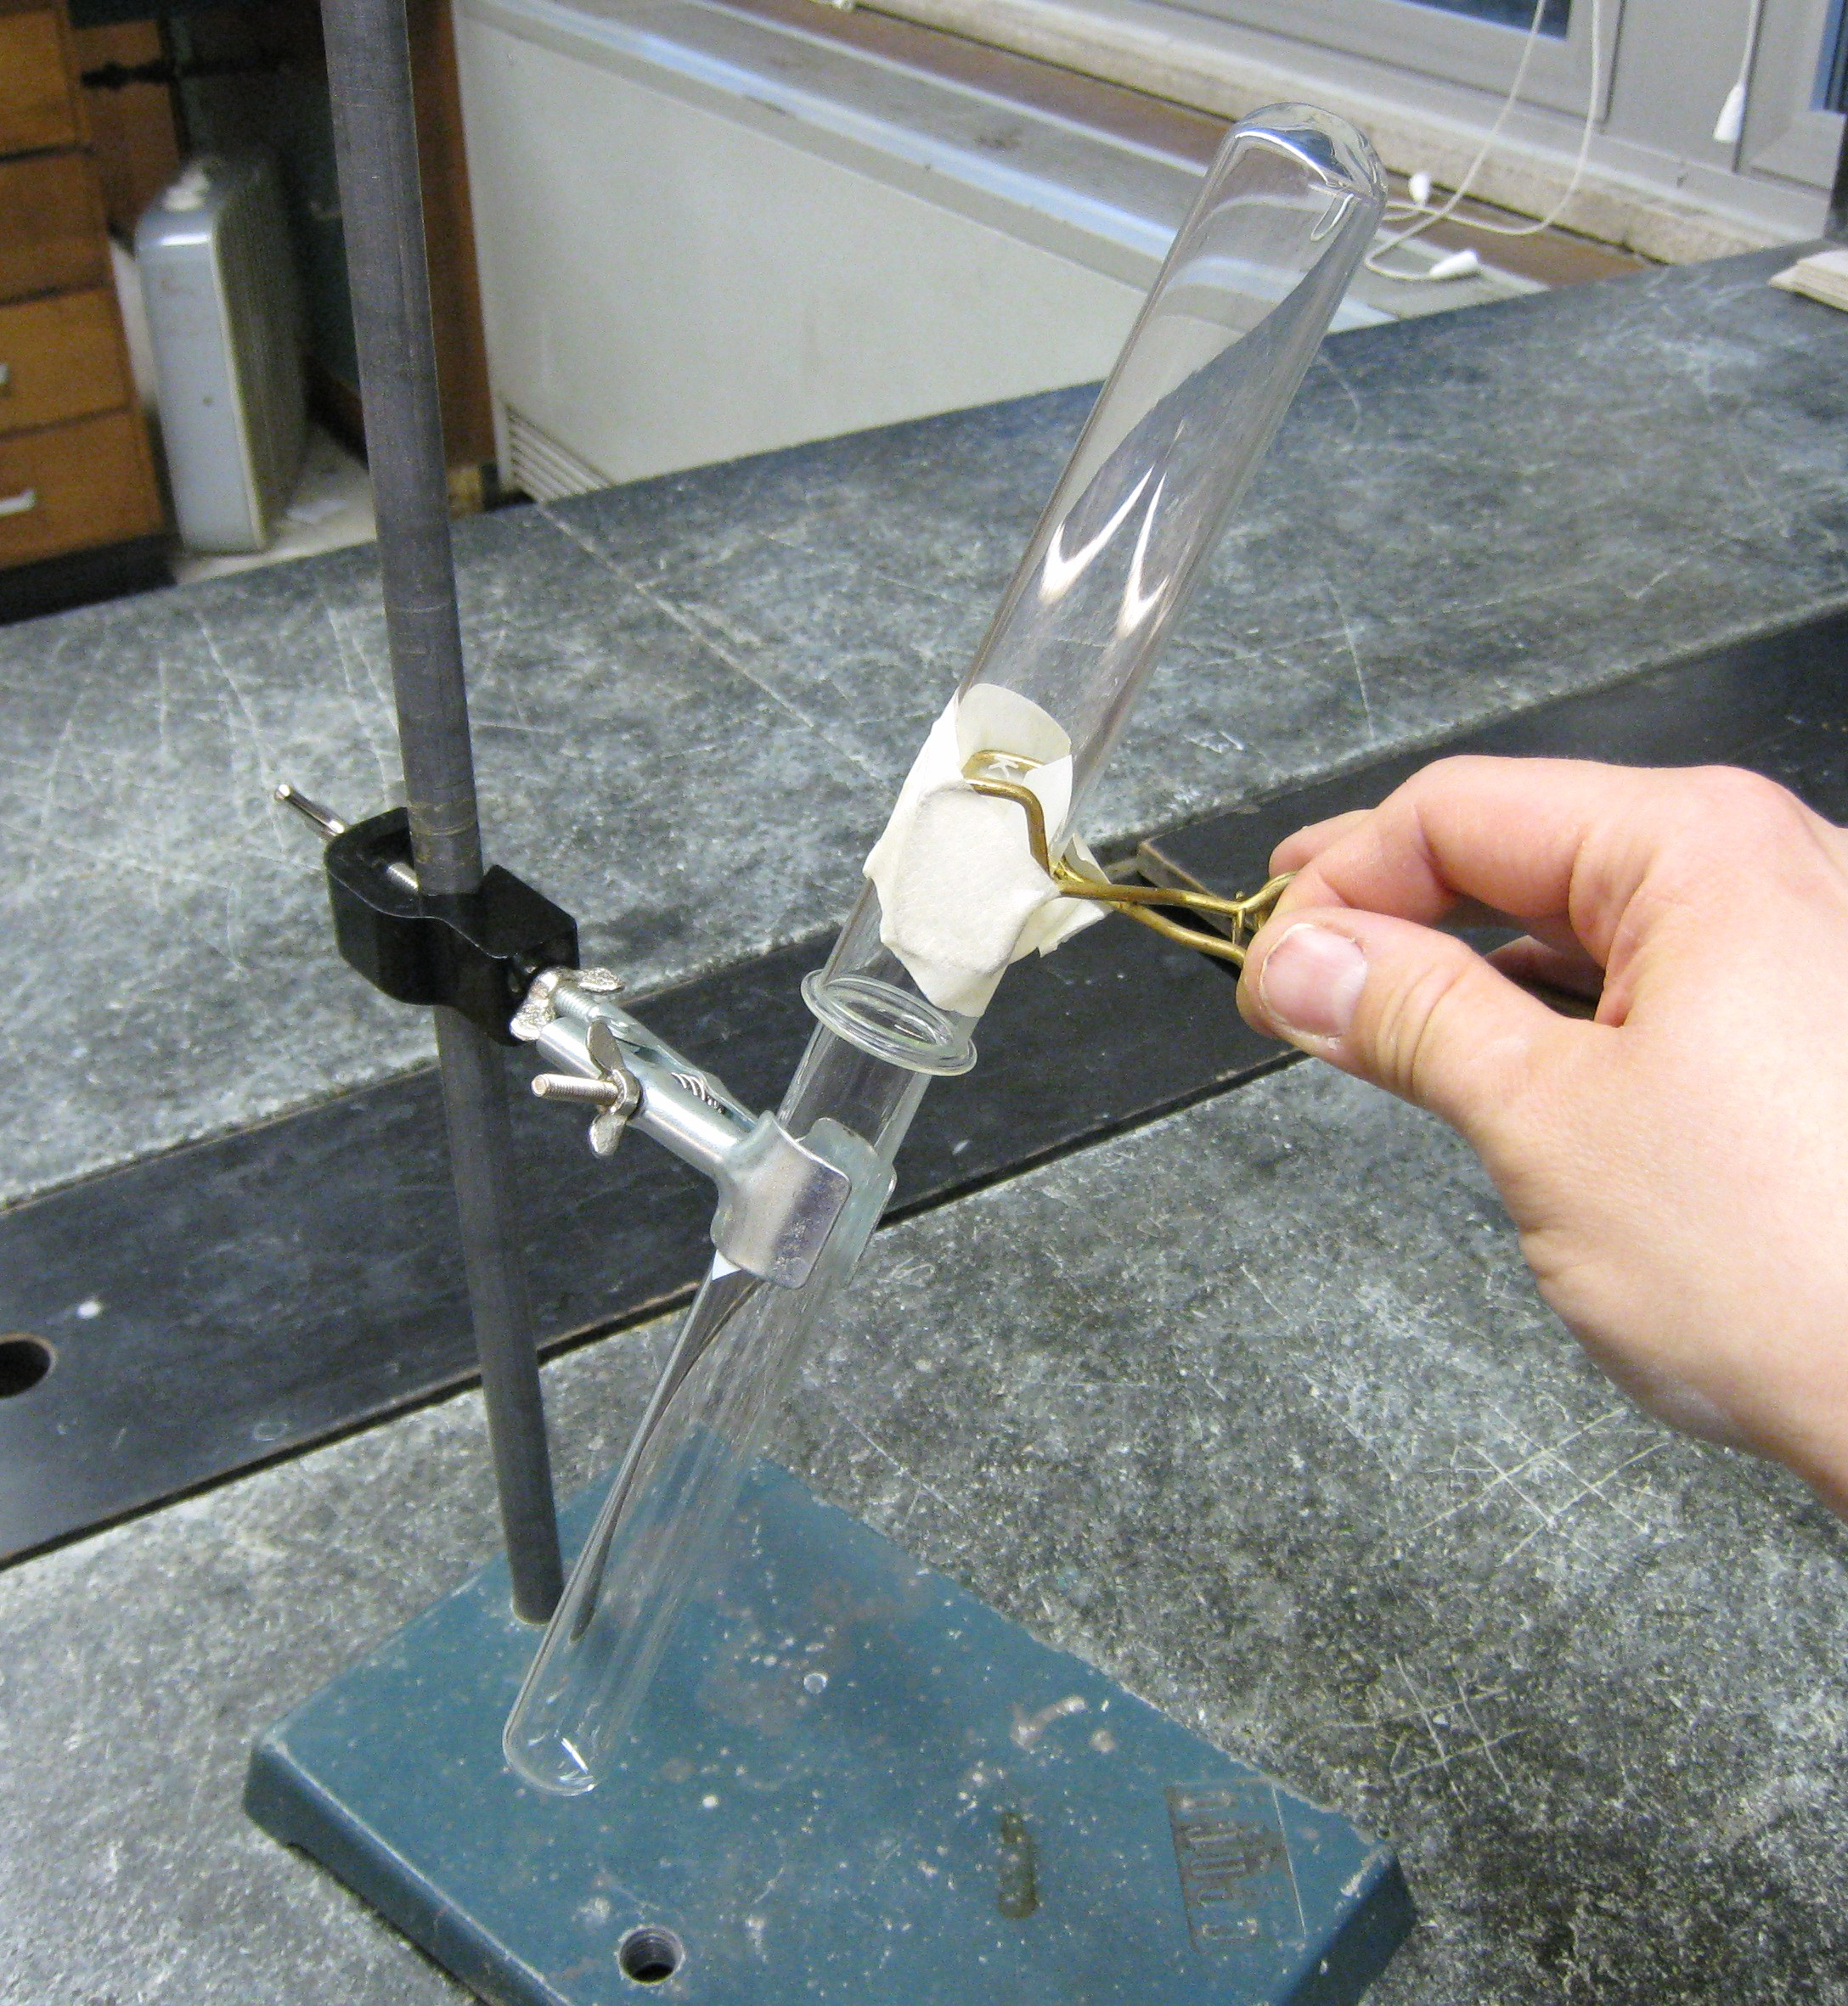
Experiment 2: Zinc and Hydrochloric Acid
Be sure to follow all safety procedures for glassware, acids, fire, etc.
Set up a ringstand with a test tube securely placed in a clamp. The test tube clamp
should be secured about 6 inches up from the base of the stand (See Figure 1).
Pick up a test tube with HCl from the teacher’s desk and place into clamp.
Obtain a small amount of zinc on scoopula (1 tablet).
Carefully slide zinc into HCl and collect any gas generated in a dry inverted
test tube. Make sure to use a large test tube holder to hold the inverted test tube as
close as possible to the test tube that is clamped on. It is advised to tape the inverted test tube to the large test tube holder to secure it on. Once the reaction has occurred for about 5 minutes, place a lit splint near opening of the inverted test tube. Make sure not to turn the inverted test tube upright, otherwise, the gas that was collected will be lost! Hint: Have lit splint ready then remove inverted test tube and place lit splint near the opening.
Name______________________________________ Date_____________
Period_________________ Lab Group #_______
Lab: Types of Chemical Reactions

Questions: Print out these questions, hand write your answers and submit in your final typed up lab report. (word document)
1. Name the five general types of chemical reactions? (5pts)

1._________________________________

2._________________________________

3._________________________________

4._________________________________

5._________________________________

2. Answer the following questions for the chemical reaction that occurred in Experiment 2: (5pts)
- Write out the word equation.

- Write out the chemical formula equation.

c. Balance the above reaction and identify all states of matter.

d. What type of chemical reaction occurred?

- What gas was generated by the chemical reaction?

Name______________________________________ Date_____________
Period_________________ Lab Group #_______
Lab: Types of Chemical Reactions

Questions (Continued): Print out these questions, hand write your answers and submit in your final typed up lab report. (word document)

3. Answer the following questions for the chemical reaction that occurred in Experiment 1: (10 pts)
a. Write out the word equation.

b. Write out the chemical formula equation.

c. Balance the above reaction and identify all states of matter. (Use Table 11.3 on pg 344)

d. What type of chemical reaction occurred?

e. What color is the Lead (II) Nitrate solution?

f. What color is the Sodium Iodide solution?

g. How did you know a chemical reaction happened?

- What was observed after 5 minutes? Describe with details.
Name______________________________________ Date_____________
Period_________________ Lab Group #_______
Lab: Types of Chemical Reactions

Questions (Continued): Print out these questions, hand write your answers and submit in your final typed up lab report. (word document)

4. Using the solubility chart, PREDICT: (4 pts)

a. MgSO₄ is soluble or insoluble ________________

b. Co(OH)₂ is soluble or insoluble ________________

c. ZnSO₄ is soluble or insoluble _________________

d. K₂CO₃ is soluble or insoluble ________________

5. Using the solubility chart, determine whether the following compounds are aqueous or solid: (6 pts)

a. PbCO3 ________________________________

b. Cu(OH)₂ __________________

c. MgI₂ ______________________

Complete the following reactions, by filling in (aq) or (s) where needed: (6 pts)

6. Na₂CO_{3(aq)} + CuSO_{4(aq)} → Na₂SO₄ + CuCO₃

7. 2KI_{(aq)} + Na₂CO_{3(aq)} → K₂CO₃ + 2Nal

8. MgCl_{2(aq)} + 2AgNO_{3(aq)} → Mg(NO₃)₂ + 2AgCl

9. In questions 6-8 circle any precipitates that have formed in the reactions. (4 pts)
Table of Solubilities in Water

Anions
S =soluble  P =slightly soluble  I =insoluble  D =decomposes  -- =unstable  Cations | Acetate C₂H₃O₂⁻¹ | Bromide Br⁻¹ | Carbonate CO₃⁻² | Chlorate ClO₃⁻¹ | Chloride Cl⁻¹ | Chromate CrO₄⁻² | Hydroxide OH⁻¹ | Iodide I⁻¹ | Nitrate NO₃⁻¹ | Oxide O⁻² | Oxalate C₂O₄⁻² | Phosphate PO₄⁻³ | Silicate SiO₃⁻² | Sulfate SO₄⁻² | Sulfide S⁻² | Sulfite SO₃⁻²
Aluminum Al⁺³ | S | S | -- | S | S | -- | I | S | S | I | I | I | I | S | D | --
Ammonium NH₄⁺¹ | S | S | S | S | S | S | -- | S | S | -- | P | S | -- | S | S | S
Antimony Sb⁺³ | -- | D | -- | -- | S | -- | -- | D | -- | P | I | -- | -- | D | D | --
Arsenic As⁺³ | -- | D | -- | -- | D | -- | -- | S | -- | P | -- | -- | -- | -- | I | --
Barium Ba⁺² | S | S | I | S | S | I | S | S | S | S | I | I | S | I | D | I
Bismuth Bi⁺³ | I | D | -- | -- | D | -- | D | I | D | I | D | I | I | D | I | --
Cadmium Cd⁺² | S | S | I | S | S | I | I | S | S | I | I | I | I | S | I | P
Calcium Ca⁺² | S | S | I | S | S | S | I | S | S | I | I | I | I | I | I | I
Chromium(III) Cr⁺³ | S | S | -- | -- | S | -- | I | I | S | I | S | P | -- | S | I | I
Cobalt(II) Co⁺² | S | S | I | S | S | I | I | S | S | I | I | I | I | S | I | I
Copper(II) Cu⁺² | S | S | I | S | S | S | I | -- | S | I | I | I | -- | S | I | --
Iron(III) Fe⁺³ | -- | S | -- | -- | S | S | I | -- | S | I | S | I | -- | S | I | --
Iron(II) Fe⁺² | S | S | I | -- | S | I | I | S | S | I | I | I | I | S | I | I
Lead(II) Pb⁺² | S | I | I | S | P | I | I | I | S | I | I | I | I | I | I | I
Magnesium Mg⁺² | S | S | I | S | S | S | I | S | S | I | I | I | I | S | D | S
Mercury(II) Hg⁺² | S | P | I | S | S | P | -- | I | S | I | I | -- | -- | D | I | --
Mercury(I) Hg₂⁺² | I | I | I | S | I | I | -- | I | D | I | I | -- | -- | I | I | --
Nickel(II) Ni⁺² | S | S | I | I | S | -- | I | S | S | I | I | I | -- | S | I | I
Potassium K⁺¹ | S | S | S | S | S | S | S | S | S | D | S | S | S | S | S | S
Silver Ag⁺¹ | P | I | I | S | I | I | -- | I | S | I | I | I | -- | I | I | I
Sodium Na⁺¹ | S | S | S | S | S | S | S | S | S | D | S | S | S | S | S | S
Strontium Sr⁺² | S | S | I | S | S | I | I | S | S | I | I | I | I | I | I | I
Zinc Zn⁺² | S | S | I | S | S | I | I | S | S | I | I | I | I | S | I | I

